**ACKNOWLEDEGEMET**

**ACKNOWLEGEMENTS**

Before we get into thick and thin of things, we the designers of project.

**“WEBSITE OF DISTANCE LEARNING”**

We would like to add a few heart felt words for the people who were part of this project in numerous ways. People who gave unending support right from the stage to the project idea were conceived.

We express our deepest thanks and gratitude to our project guide **Prof. Roshni Mahajan & Mrs.Shilpa Inogle** for approval of this project and guiding us throughout this project and providing us with useful suggestions as and when needed. His extensive and timely guidance has helped us towards betterment of this project.

There are times in such projects when your clock beats your time again and again and you run of time and dangling to complete the project. Our **H.O.D MR.D.V.Chavak** and Principal **MR.A.B.PATIL** made us endure such times with their unfailing support and help.

**By:**

**Mr. NITIN .R.MOTWANI**

**Mr. JATIN .R. KATARIA**

**Mr. MOHIT .J. KATARIA**

**Mr. RAHUL .R.DHAMEJA**

**PREFACE**

**PREFACE**

Our Project has been accomplished in

ASP & Hyper Text Markup Language

Our Project provides the information about the Distance Learning

(E-Learning).

The Aim of our project is to give optimal information about Distance Learning. And also to implement Computerization in lower sectors.

The Other parts included in our project are Live Streaming, E-Attendance, E-Library, Online Examination, Notification and Activities of Institute.

Our project report has the ability to satisfy the needs of reader. For better understanding our project report is divided into various sections.

We have covered as in depth description of every module in our project along with future aspects.

Our project will serve as guidance to the users and experts alike,

According there requirements.

The report also presents the detailed information of section that will help the user to know about the various topics covered by us in the project.

Thus, this report helps a visitor or user to better understand our projects.

**TABLE OF CONTENTS**

|  |  |  |
| --- | --- | --- |
| SR. NO | CONTENT | Page No |
| 1. | **INTRODUCTION** | **2** |
|  |  |  |
| 2. | **SYSTEM ANALYSIS** | **4** |
|  |  |  |
| 3. | **FLOW DIAGRAM** | **6** |
|  |  |  |
| 4. | **DIAGRAMS** |  |
|  |  |  |
|  | **DATABASE DESIGN** |  |
|  |  |  |
| 5. | **TECHNOLOGIES**   1. **Languages** 2. **Software Require** |  |
|  |  |  |
| 6. | **TESTING** |  |
|  |  |  |
| 7. | **OUTPUT** |  |
|  |  |  |
|  | **ADVANTAGES** |  |
|  |  |  |
| 8. | **FUTURE ENHANCEMENTS** |  |
|  |  |  |
| 9. | **BIBLIOGRAPHY/REFRENCE** |  |
|  |  |  |
| 10. | **CONCLUSION** |  |

**INTRODUCTION**

**INTRODUCTION**

**Distance Learning:** Distance Learning is a method of studying in which lectures are broadcast or lessons are conducted by correspondence, without the student needing to attend a school or college.

The Project **Distance Learning** is Web site of Private Institute For Programming Languages like C, C++, Java.

Project (Web Site) Contains Following Feature:

* Live Streaming: Streaming video is content sent in compressed form over the Internet and displayed by the viewer in real time. With streaming video or streaming media, a Web user does not have to wait to download a file to play it. Instead, the media is sent in a continuous stream of data and is played as it arrives.
* E-Library: A digital library is a collection of documents in organized electronic form, available on the Internet. Depending on the specific library, a user may be able to access magazine articles, books, papers, images, sound files, and videos.
* E-Attendance: Online attendance system Auto Attendance Logs import Quick attendance setup, Easy Learning   
  Supports Multi Date and Language ID Card Attendance Identification Finger Print Biometrics Attendance Password Attendance System.
* Online Examination: online examination system is designed for educational institutes like schools, colleges, and private institutes to conduct logic tests of their students on a regular basis.

Our Project Consist of Certain :-

* Main Page : Contains the look of our home page with highlights.
* Signup Page: Page where Student can create new Account.
* SignIn Page: It is First Page to enter Distance Learning. If and only when Student has Login Information (Email/Password).
* Features: Page describes details of Feature of Site.
* Contact us: Page Where User/Customer/Student will give Feedback/Suggestion or can ask any Doubt/Question.
* Live Lecture: On this web page open only when live Lecture going on.
* E-Library: Page contains C,C++,Java pdf
* About Us: Contains the links of introduction , History and Developers Details.
* Distance Learning: After Sign in Student redirected to this page. Page contains schedule, notification, news, achievements and links of Live Lecture, Examination and Library.
* Attendance & Marks Details: Page contains Student Attendance Details & Marks of Test

But without Sign In/Log in user can see only two pages that are

Main page & Features.

**SYSTEM ANALYSIS**

**SYSTEM ANALYSIS**

Every Project must be controlled by plan of working. Planning is dynamic and continuous activity it ends only when project ends.

# The main purpose of our project is to develop a website in such way that it fulfills all the requirements of customers.

# ****Project Definition****

Organizations have a need to communicate to stakeholders their positions on issues and make audiences aware of their products and services. Many times the communication need, such as a Web site, is triggered by a change of strategic direction or a new offering. Identifying the reasons of the site’s existence and what it is supposed to achieve are the first step in the process. The goals and objectives that are established at the outset of the project inform all future decisions, from site structure and naming conventions used in the navigation to the visual design of the site. The first step in the definition process is interviewing the organization’s stakeholders to identify the strategic goals of the site, understand key audience needs and identify key competitors. The goal of the definition step is to identify three measurable key outcomes that are directly related to the strategic goals of the organization. The challenge in this step is limiting the number of goals. Most organizations will have more goals than they know what to do with, and each department believes their individual unit’s goals are the most important. Being able to bring focus to organizational goals will make developing the site easier and make the final product more effective.

Once all the information and assessments gathered from the stakeholder interviews are completed, they should be collected in a well-formatted project brief. The brief contains the following elements.

* + - **Project summary:** Outlines the general overview of the project and Sites overview, what is basic need of any **E-Learning** site. Gather the information & make one document of it.
    - **Goals:** At this point we were discussed the **main goals of project.** Like Live Streaming, E-Library, Examination and all.
    - **Competition:** Having website today’s world is not big deal, but having website with customer attraction is the one that matters the most.

**Project Scope:** In this stage we have collected the information about what are the End user’s needs for this website. For this we are keeping the survey many Others Distance Learning sites and the accordingly that what should be present in our website. We have decide to provide detailed information about all the projects, service, teamwork, streaming.

* **Economic Feasibility:**

This is related to cost/Benefit analysis at this time can’t say exact cost of our project but we can assume the cost of our project nearly about upto 4000/- to 5000/-

* **Technical Feasibility:**

This involves the financial consideration accommodate technical enhancements. We have studied their earlier website and decided to what extend we can enhance our website.

* **Behavioral Feasibility:**

This involves that the introduction of website require special effort to educate

# ****Wireframes and Site Architecture (Sitemap)****

Site architecture includes the sitemap and wireframes of pages. Creating the sitemap ensures that you’ve considered all the key pages in the site, showing their relationship to each other and defining how the sties overall navigation should be structured. Wireframes provide a detailed view of the content that will appear on each page. Although they do not show any actual design elements, the wireframes provide a guide for defining content hierarchy on the page.

# ****Visual Design****

# **After the planning of sitemap we has discussed about the look of every single webpage.**

**Requirement Analysis:**

* **Minimum Hardware Requirement**

1. Pc with Pentium processor
2. 32mb minimum RAM memory
3. Color Monitor
4. 10 GB HDD

* **Minimum Software Requiremnt**

1. Internet Browser(Chrome)
2. Visual Studio 2008
3. Microsoft Access
4. Microsoft Word
5. Corel Draw

**Rough Idea:**

The rough idea of our project consists of a teacher who resides on a main server and the other end users residing on individual terminals. The students would be assigned a particular link for learning purpose each time for specific time constraints. The doubts of the teachers would be clarified by the teacher via a chat box provided in the software. The output screens of all the students can be viewed by the teacher at the server computer which leads to a two-way communication. The message by the teacher from the server computer can be broadcasted to the students, but the student can only contact the teacher for the clarification purpose in a unicast communication way i.e. student can't communicate with the other peer students.

**FLOW-CHART**

**Flow-Chart Diagram Of Project**:

1. For Sign In ( Create new Account)



1. **For After Sign Up**



**DIAGRAMS**

**Use Case Diagram of Project:**

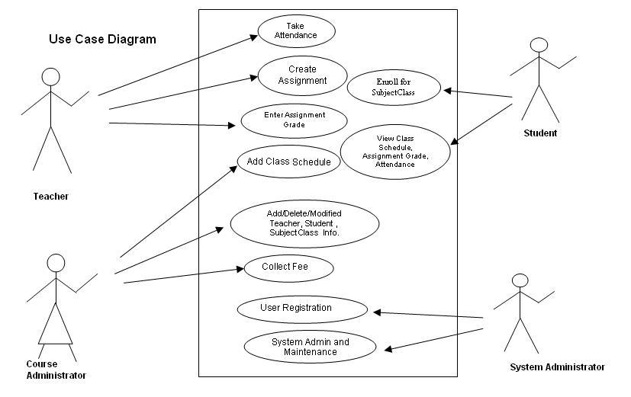

**DFD DIGRAMS**

**DFD 0 for Distance Learning System**

Student

Distance Learning

**DFD 1(DATA FLOW DIAGRAM LEVEL 1)**

**for Distance Learning System**

**Student**

**USER DATABASE**

**E-Library**

**Teacher**

**DFD 2(DATA FLOW DAIGRAM LEVEL 2)**

**FOR DISTANCE LEARNING SYSTEM**

**For Login Module:**

Verification Data

**For Live Stream Module:**

**Student**

**Teacher**

**TECHNOLOGIES USED**

**LANGUAGES**

The mostly used languages in our project are:

* HTML - Hyper Text Markup Languages
* CSS - Cascading Style Sheet
* ASP – Active Server Page
* VBSCRIPT

Information About these languages is given in the following pages.

**ABOUT HTML:-**

HYPER TEXT MARKUP LANGUAGE:

“HTML is Markup language for describing web documents (web pages). **HTML** stands for Hyper Text Markup Language.**HTML** documents are describing by **HTML** tags. Each **HTML** tag describes different document content.”

It is the simplest part of what webpages on the World Wide Web. It is a markup languages that people can read, and special language that tells computer programs what to do.

A web browser is the program that reads the special language in **HTML**. This Language tells web browser how the web page should look. The web page can include writing, links, pictures and even sound and video. It can also have writing that is shown in the web page, which tells people about the web page.

For eg:- the name of person who made it i.e. the creator of the website.

Writing **HTML**:

You can’t make html with a computer program called a html editor because html is dumb, you make it in a text editor. There are also computer programs that let you draw web page the way you want

It to liik and the programs make html for you.

Sample **HTML:**

**HTML** tells the browser what to show by using tag. Tags start with < and end with >. An example is <br> tag. The line break tag, which causes a new line.

Most tags have an opening tag to tell the browser where to start something, and an ending tag to tell the browser where to end. An Example is <p> starts a new paragraph and ends </p> a paragraph.

**ABOUT CSS**

What is CSS?

* CSS stands for Cascading Style Sheets
* CSS describes how HTML elements are to be displayed on screen, paper, or in other media
* CSS saves a lot of work. It can control the layout of multiple web pages all at once.
* External stylesheets are stored in CSS files.

**Cascading Style Sheets** (**CSS**) is a [style sheet language](https://en.wikipedia.org/wiki/Style_sheet_language) used for describing the [presentation](https://en.wikipedia.org/wiki/Presentation_semantics) of a document written in a [markup language](https://en.wikipedia.org/wiki/Markup_language).[[1]](https://en.wikipedia.org/wiki/Cascading_Style_Sheets#cite_note-1) Although most often used to set the visual style of [web pages](https://en.wikipedia.org/wiki/Web_page) and user interfaces written in [HTML](https://en.wikipedia.org/wiki/HTML) and [XHTML](https://en.wikipedia.org/wiki/XHTML), the language can be applied to any [XML](https://en.wikipedia.org/wiki/XML) document, including [plain XML](https://en.wikipedia.org/wiki/Plain_Old_XML), [SVG](https://en.wikipedia.org/wiki/Scalable_Vector_Graphics) and [XUL](https://en.wikipedia.org/wiki/XUL), and is applicable to rendering in [speech](https://en.wikipedia.org/wiki/Speech_synthesis), or on other media. Along with HTML and JavaScript, CSS is a cornerstone technology used by most websites to create visually engaging webpages, user interfaces for [web applications](https://en.wikipedia.org/wiki/Web_applications), and user interfaces for many mobile applications.[[2]](https://en.wikipedia.org/wiki/Cascading_Style_Sheets#cite_note-2)

**CSS** is designed primarily to enable [the separation of document content from document presentation](https://en.wikipedia.org/wiki/Separation_of_presentation_and_content), including aspects such as the [layout](https://en.wikipedia.org/wiki/Page_layout), [colors](https://en.wikipedia.org/wiki/Color), and [fonts](https://en.wikipedia.org/wiki/Typeface).[[3]](https://en.wikipedia.org/wiki/Cascading_Style_Sheets#cite_note-3) This separation can improve content [accessibility](https://en.wikipedia.org/wiki/Accessibility), provide more flexibility and control in the specification of presentation characteristics, enable multiple **HTML** pages to share formatting by specifying the relevant CSS in a separate **.css** file, and reduce complexity and repetition in the structural content.

* Why Use CSS?
* CSS is used to define styles for your web pages, including the design, layout and variations in display for different devices and screen sizes.
* CSS Solved a Big Problem
* HTML was NEVER intended to contain tags for formatting a web page!

HTML was created to **describe the content** of a web page, like:

<h1>This is a heading</h1>

<p>This is a paragraph.</p>

When tags like <font>, and color attributes were added to the HTML 3.2 specification, it started a nightmare for web developers. Development of large websites, where fonts and color information were added to every single page, became a long and expensive process.

To solve this problem, the World Wide Web Consortium (W3C) created CSS.

CSS removed the style formatting from the HTML page!

* CSS Saves a Lot of Work!
* The style definitions are normally saved in external .css files. With an external stylesheet file, you can change the look of an entire website by changing just one file!

**ABOUT ASP**

## What is ASP?

* ASP stands for **A**ctive **S**erver **P**ages
* ASP is a Microsoft Technology
* ASP is a program that runs inside **IIS**
* IIS stands for **I**nternet **I**nformation **S**ervices
* IIS comes as a free component with **Windows 2000**
* IIS is also a part of the **Windows NT 4.0 Option Pack**
* The Option Pack can be **downloaded** from Microsoft
* **PWS** is a smaller - but fully functional - version of IIS
* PWS can be found on your **Windows 95/98 CD**

## ASP Compatibility

* To run IIS you must have Windows NT 4.0 or later
* To run PWS you must have Windows 95 or later
* ChiliASP is a technology that runs ASP without Windows OS
* InstantASP is another technology that runs ASP without Windows

## What is an ASP File?

* An ASP file is just the same as an HTML file
* An ASP file can contain text, HTML, XML, and scripts
* Scripts in an ASP file are executed on the server
* An ASP file has the file extension ".asp"

## How Does ASP Differ from HTML?

* When a browser requests an HTML file, the server returns the file
* When a browser requests an ASP file, IIS passes the request to the ASP engine. The ASP engine reads the ASP file, line by line, and executes the scripts in the file. Finally, the ASP file is returned to the browser as plain HTML

## What can ASP do for you?

* Dynamically edit, change, or add any content of a Web page
* Respond to user queries or data submitted from HTML forms
* Access any data or databases and return the results to a browser
* Customize a Web page to make it more useful for individual users
* The advantages of using ASP instead of CGI and Perl, are those of simplicity and speed
* Provide security - since ASP code cannot be viewed from the browser
* Clever ASP programming can minimize the network traffic

**Active Server Pages** (**ASP**), later known as **Classic ASP** or **ASP Classic**, is [Microsoft](https://en.wikipedia.org/wiki/Microsoft)'s first [server-side](https://en.wikipedia.org/wiki/Server-side_scripting) [script engine](https://en.wikipedia.org/wiki/Active_Scripting) for [dynamically generated web pages](https://en.wikipedia.org/wiki/Dynamic_web_page). [ASP.NET](https://en.wikipedia.org/wiki/ASP.NET), first released in January 2002, has superseded ASP.

|  |  |
| --- | --- |
| **Active Server Pages (ASP)** | |
| [**Developer(s)**](https://en.wikipedia.org/wiki/Software_developer) | [Microsoft](https://en.wikipedia.org/wiki/Microsoft) |
| [**Stable release**](https://en.wikipedia.org/wiki/Software_release_life_cycle) | 3.0 / February 17, 2000; 16 years ago |
| **Development status** | Discontinued |
| [**Type**](https://en.wikipedia.org/wiki/List_of_software_categories) | [Web application framework](https://en.wikipedia.org/wiki/Web_application_framework) |
| [**License**](https://en.wikipedia.org/wiki/Software_license) | [Commercial](https://en.wikipedia.org/wiki/Commercial_software) [proprietary software](https://en.wikipedia.org/wiki/Proprietary_software) |

|  |  |
| --- | --- |
| **Active Server Pages** | |
| [**Filename extension**](https://en.wikipedia.org/wiki/Filename_extension) | .asp |
| **Developed by** | [Microsoft](https://en.wikipedia.org/wiki/Microsoft) |

**ABOUT VBSCIPT**

**VBScript** (*"Visual Basic Scripting Edition"*) is an [Active Scripting](https://en.wikipedia.org/wiki/Active_Scripting) language developed by [Microsoft](https://en.wikipedia.org/wiki/Microsoft) that is modeled on [Visual Basic](https://en.wikipedia.org/wiki/Visual_Basic). It is designed as a "lightweight" language with a fast interpreter for use in a wide variety of Microsoft environments. VBScript uses the [Component Object Model](https://en.wikipedia.org/wiki/Component_Object_Model) to access elements of the environment within which it is running; for example, the Filesystem Object (FSO) is used to delete files.

VBScript has been installed by default in every desktop release of [Microsoft Windows](https://en.wikipedia.org/wiki/Microsoft_Windows) since [Windows 98](https://en.wikipedia.org/wiki/Windows_98);[]](https://en.wikipedia.org/wiki/VBScript#cite_note-1) in [Windows Server](https://en.wikipedia.org/wiki/Windows_Server) since [Windows NT 4.0 Option Pack](https://en.wikipedia.org/wiki/Windows_NT_4.0#Option_Pack);[]](https://en.wikipedia.org/wiki/VBScript#cite_note-2) and optionally with [Windows CE](https://en.wikipedia.org/wiki/Windows_CE) (depending on the device it is installed on).

A VBScript script must be executed within a [host environment](https://en.wikipedia.org/wiki/Hosting_environment), of which there are several provided with Microsoft Windows, including: [Windows Script Host](https://en.wikipedia.org/wiki/Windows_Script_Host) (WSH), [Internet Explorer](https://en.wikipedia.org/wiki/Internet_Explorer) (IE), and [Internet Information Services](https://en.wikipedia.org/wiki/Internet_Information_Services)(IIS). Additionally, the VBScript hosting environment is embeddable in other programs, through technologies such as the Microsoft Script Control (msscript.ocx)

Microsoft VBScript (Visual Basic Script) is a general-purpose, lightweight and active scripting language developed by Microsoft that is modelled on Visual Basic. Nowadays, VBScript is the primary scripting language for Quick Test Professional (QTP), which is a test automation tool.

## Examples

### Hello, World

The simplest way to output "Hello World":

MsgBox "Hello, World" *'If Visual Basic version isn't 6.0 or lower, you can also write it like this : MsgBox("Hello, World")*

This would be saved as a .vbs file or .vbe and executed using cscript.exe or wscript.exe.

A more elaborate example, showing the use of MsgBox as a function (returning a result), and the use of three parameters, including the use of constants in the second parameter.

**Dim** x

*‘These three produce the same result. However, the use of constants as in the third line*

*' is considered best practice.*

x = MsgBox("Hello World:Text",1+64+4096,"Hello World:Title")

x = MsgBox("Hello World:Text",4161,"Hello World:Title")

x = MsgBox("Hello World:Text", vbOKCancel+vbInformation+vbSystemModal, _

"Hello World:Title")

*' Tip:MsgBox(Prompt,[Icon + Button],[Title],[Helpfile,Context])*

*‘Presents the number corresponding to the button pressed. Different constants will produce*

*‘different behaviours. For example, vbOKCancel specifies two buttons in the dialogue box,*

*' whereas vbYesNoCancel specifies three.*

x = MsgBox("Hello World:Text", vbYesNoCancel+vbInformation,"Hello World:Title")

MsgBox "The result is " & x

### Variable type

**Dim** a **As** Integer *'This variable can ONLY receive value as integer or you'll use Val function to change value type to integer*

**Dim** a **As** String *'This variable can ONLY receive value as string or you'll use Str function to change value type to string*

**ABOUT ASP.NET**

**ASP.NET** is an [open-source](https://en.wikipedia.org/wiki/Open_source)[server-side](https://en.wikipedia.org/wiki/Server-side_scripting) [web application framework](https://en.wikipedia.org/wiki/Web_application_framework) designed for [web development](https://en.wikipedia.org/wiki/Web_development) to produce [dynamic web pages](https://en.wikipedia.org/wiki/Dynamic_web_page). It was developed by [Microsoft](https://en.wikipedia.org/wiki/Microsoft) to allow [programmers](https://en.wikipedia.org/wiki/Programmer) to build dynamic [web sites](https://en.wikipedia.org/wiki/Web_site), [web applications](https://en.wikipedia.org/wiki/Web_application) and [web services](https://en.wikipedia.org/wiki/Web_service).

It was first released in January 2002 with version 1.0 of the [.NET Framework](https://en.wikipedia.org/wiki/.NET_Framework), and is the successor to Microsoft's [Active Server Pages](https://en.wikipedia.org/wiki/Active_Server_Pages) (ASP) technology. ASP.NET is built on the [Common Language Runtime](https://en.wikipedia.org/wiki/Common_Language_Runtime) (CLR), allowing programmers to write ASP.NET code using any supported [.NET language](https://en.wikipedia.org/wiki/List_of_CLI_languages). The ASP.NET [SOAP](https://en.wikipedia.org/wiki/SOAP) extension framework allows ASP.NET components to process SOAP messages.

ASP.NET is in the process of being re-implemented as a modern and modular [web framework](https://en.wikipedia.org/wiki/Web_framework), together with other frameworks like [Entity Framework](https://en.wikipedia.org/wiki/Entity_Framework). The new framework will make use of the new open-source [.NET Compiler Platform](https://en.wikipedia.org/wiki/.NET_Compiler_Platform) (code-name "Roslyn") and be [cross platform](https://en.wikipedia.org/wiki/Cross_platform). [ASP.NET MVC](https://en.wikipedia.org/wiki/ASP.NET_MVC), ASP.NET Web API, and ASP.NET Web Pages (a platform using only [Razor](https://en.wikipedia.org/wiki/ASP.NET_Razor) pages) will merge into a unified MVC 6.[[4]](https://en.wikipedia.org/wiki/ASP.NET#cite_note-asp.net-4) The project is called[ASP.NET vNext](https://en.wikipedia.org/wiki/ASP.NET_vNext).

ASP COMPARED WITH ASP.NET

* Compiled code means applications run faster with more design-time errors trapped at the development stage.
* Significantly improved run-time error handling, making use of [exception handling](https://en.wikipedia.org/wiki/Exception_handling) using try-catch blocks.
* Similar metaphors to Microsoft Windows applications such as controls and events.
* An extensive set of controls and class libraries, as well as user-defined controls, allow the rapid building of applications. Layout of these controls on a page is easier because most of it can be done visually in most editors.
* ASP.NET uses the multi-language abilities of the .NET [Common Language Runtime](https://en.wikipedia.org/wiki/Common_Language_Runtime), allowing Web pages to be coded in VB.NET, C#, J#, Delphi.NET etc.
* Ability to cache the whole page or just parts of it to improve performance.
* Ability to use the [code-behind](https://en.wikipedia.org/wiki/ASP.NET#Code-behind_model) development model to separate business logic from presentation.
* Ability to use true [object-oriented](https://en.wikipedia.org/wiki/Object-oriented_programming) design for programming pages and controls
* If an ASP.NET application [leaks memory](https://en.wikipedia.org/wiki/Memory_leak), the ASP.NET runtime unloads the AppDomain hosting the erring application and reloads the application in a new AppDomain.
* [Session state](https://en.wikipedia.org/wiki/ASP.NET#Session_state) in ASP.NET can be saved in a [Microsoft SQL Server](https://en.wikipedia.org/wiki/Microsoft_SQL_Server) database or in a separate process running on the same machine as the Web server or on a different machine. That way session values are not lost when the Web server is reset or the ASP.NET worker process is recycled.

**SOFTWARES UESD**

The Mostly Used Software for the Project are:

* Microsoft Visual Studio 2008
* MS ACCESS
* ASP.NET Server
* Corel Draw X7
* Google Chrome
* Adobe Flash Media Live Encoder 3.2

**About MICROSOFT VISUAL STUDIO 2008**

**Microsoft Visual Studio** is an [integrated development environment](https://en.wikipedia.org/wiki/Integrated_development_environment) (IDE) from [Microsoft](https://en.wikipedia.org/wiki/Microsoft). It is used to develop [computer programs](https://en.wikipedia.org/wiki/Computer_program) for [Microsoft Windows](https://en.wikipedia.org/wiki/Microsoft_Windows), as well as [web sites](https://en.wikipedia.org/wiki/Web_site), [web applications](https://en.wikipedia.org/wiki/Web_application) and [web services](https://en.wikipedia.org/wiki/Web_service). Visual Studio uses Microsoft software development platforms such as [Windows API](https://en.wikipedia.org/wiki/Windows_API), [Windows Forms](https://en.wikipedia.org/wiki/Windows_Forms), [Windows Presentation Foundation](https://en.wikipedia.org/wiki/Windows_Presentation_Foundation), [Windows Store](https://en.wikipedia.org/wiki/Windows_Store) and [Microsoft Silverlight](https://en.wikipedia.org/wiki/Microsoft_Silverlight). It can produce both [native code](https://en.wikipedia.org/wiki/Native_code)and [managed code](https://en.wikipedia.org/wiki/Managed_code).

Visual Studio includes a [code editor](https://en.wikipedia.org/wiki/Code_editor) supporting [IntelliSense](https://en.wikipedia.org/wiki/IntelliSense) (the [code completion](https://en.wikipedia.org/wiki/Code_completion) component) as well as [code refactoring](https://en.wikipedia.org/wiki/Code_refactoring). The integrated [debugger](https://en.wikipedia.org/wiki/Microsoft_Visual_Studio_Debugger) works both as a source-level debugger and a machine-level debugger. Other built-in tools include a forms designer for building [GUI](https://en.wikipedia.org/wiki/GUI) applications, [web designer](https://en.wikipedia.org/wiki/Web_designer), [class](https://en.wikipedia.org/wiki/Class_(computing)) designer, and [database schema](https://en.wikipedia.org/wiki/Database_schema) designer. It accepts plug-ins that enhance the functionality at almost every level—including adding support for [source-control](https://en.wikipedia.org/wiki/Source_control) systems (like [Subversion](https://en.wikipedia.org/wiki/Subversion_(software))) and adding new toolsets like editors and visual designers for [domain-specific languages](https://en.wikipedia.org/wiki/Domain-specific_language) or toolsets for other aspects of the [software development lifecycle](https://en.wikipedia.org/wiki/Software_development_lifecycle) (like the [Team Foundation Server](https://en.wikipedia.org/wiki/Team_Foundation_Server) client: Team Explorer).

Visual Studio supports different [programming languages](https://en.wikipedia.org/wiki/Programming_language) and allows the code editor and debugger to support (to varying degrees) nearly any programming language, provided a language-specific service exists. Built-in languages include [C](https://en.wikipedia.org/wiki/C_(programming_language)),[[5]](https://en.wikipedia.org/wiki/Microsoft_Visual_Studio#cite_note-5) [C++](https://en.wikipedia.org/wiki/C%2B%2B) and [C++/CLI](https://en.wikipedia.org/wiki/C%2B%2B/CLI) (via [Visual C++](https://en.wikipedia.org/wiki/Visual_C%2B%2B)), [VB.NET](https://en.wikipedia.org/wiki/VB.NET) (via [Visual Basic .NET](https://en.wikipedia.org/wiki/Visual_Basic_.NET)), [C#](https://en.wikipedia.org/wiki/C_Sharp_(programming_language)) (via [Visual C#](https://en.wikipedia.org/wiki/Visual_C_Sharp)), and [F#](https://en.wikipedia.org/wiki/F_Sharp_(programming_language)) (as of Visual Studio 2010[[6]](https://en.wikipedia.org/wiki/Microsoft_Visual_Studio#cite_note-6)). Support for other languages such as [M](https://en.wikipedia.org/wiki/MUMPS), [Python](https://en.wikipedia.org/wiki/IronPython), and Ruby among others is available via language services installed separately. It also supports [XML](https://en.wikipedia.org/wiki/XML)/[XSLT](https://en.wikipedia.org/wiki/XSLT), [HTML](https://en.wikipedia.org/wiki/HTML)/[XHTML](https://en.wikipedia.org/wiki/XHTML), [JavaScript](https://en.wikipedia.org/wiki/JavaScript) and [CSS](https://en.wikipedia.org/wiki/Cascading_Style_Sheets). Java (and J#) were supported in the past.

Before Visual Studio 2015, Commercial versions of Visual Studio were available for free to students via Microsoft's [DreamSpark](https://en.wikipedia.org/wiki/DreamSpark) program, when only commercial versions supported plugins.[[7]](https://en.wikipedia.org/wiki/Microsoft_Visual_Studio#cite_note-7) Starting with Visual Studio 2015, Microsoft provides "Community" editions of its Visual Studio at no cost to any one. The Community edition supports installing plugins.

|  |  |
| --- | --- |
| **Microsoft Visual Studio** | |
| [Visual Studio 2012 logo and wordmark.svg](https://en.wikipedia.org/wiki/File:Visual_Studio_2012_logo_and_wordmark.svg) | |
| [Visual Studio 2013 EN.png](https://en.wikipedia.org/wiki/File:Visual_Studio_2013_EN.png)  Screenshot of Visual Studio 2013, editing a program's source code in [C++](https://en.wikipedia.org/wiki/C%2B%2B) | |
| [**Developer(s)**](https://en.wikipedia.org/wiki/Software_developer) | [Microsoft](https://en.wikipedia.org/wiki/Microsoft) |
| [**Stable release**](https://en.wikipedia.org/wiki/Software_release_life_cycle) | 2015 Update 1 (November 30, 2015; 3 months ago) [[±]](https://en.wikipedia.org/wiki/Template:Latest_stable_software_release/Microsoft_Visual_Studio?action=edit)[[1]](https://en.wikipedia.org/wiki/Microsoft_Visual_Studio#cite_note-1) |
| **Written in** | [C++](https://en.wikipedia.org/wiki/C%2B%2B) and [C#](https://en.wikipedia.org/wiki/C_Sharp_(programming_language))[[2]](https://en.wikipedia.org/wiki/Microsoft_Visual_Studio#cite_note-2) |
| [**Operating system**](https://en.wikipedia.org/wiki/Operating_system) | * [Windows 7](https://en.wikipedia.org/wiki/Windows_7) and later * [Windows Server 2008 R2](https://en.wikipedia.org/wiki/Windows_Server_2008_R2)[[3]](https://en.wikipedia.org/wiki/Microsoft_Visual_Studio#cite_note-3) |
| **Available in** | Chinese, English, French, Portuguese, German, Italian, Japanese, Korean, Spanish and Russian |
| [**Type**](https://en.wikipedia.org/wiki/List_of_software_categories) | [Integrated development environment](https://en.wikipedia.org/wiki/Integrated_development_environment) |
| [**License**](https://en.wikipedia.org/wiki/Software_license) | [Proprietary software](https://en.wikipedia.org/wiki/Proprietary_software) **Express edition:** [Registerware](https://en.wikipedia.org/wiki/Registerware" \o "Registerware) **Community edition:**[Registerware](https://en.wikipedia.org/wiki/Registerware) **Other editions:** [Trialware](https://en.wikipedia.org/wiki/Trialware" \o "Trialware)[[4]](https://en.wikipedia.org/wiki/Microsoft_Visual_Studio#cite_note-4) |
| **Website** | [visualstudio.com](http://visualstudio.com/) |

**ABOUT MS-ACCESS**

**Microsoft Access** is a [DBMS](https://en.wikipedia.org/wiki/DBMS) (also known as Database Management System) from [Microsoft](https://en.wikipedia.org/wiki/Microsoft) that combines the [relational](https://en.wikipedia.org/wiki/Relational_database) [Microsoft Jet Database Engine](https://en.wikipedia.org/wiki/Microsoft_Jet_Database_Engine) with a [graphical user interface](https://en.wikipedia.org/wiki/Graphical_user_interface) and software-development tools. It is a member of the [Microsoft Office](https://en.wikipedia.org/wiki/Microsoft_Office) suite of applications, included in the Professional and higher editions or sold separately.

Microsoft Access stores data in its own format based on the Access Jet Database Engine. It can also import or link directly to [data](https://en.wikipedia.org/wiki/Data) stored in other applications and databases.[[1]](https://en.wikipedia.org/wiki/Microsoft_Access#cite_note-ms-import-1)

[Software developers](https://en.wikipedia.org/wiki/Software_developer) and [data architects](https://en.wikipedia.org/wiki/Data_architect) can use Microsoft Access to develop [application software](https://en.wikipedia.org/wiki/Application_software), and "[power users](https://en.wikipedia.org/wiki/Power_users)" can use it to build software applications. Like other [Office applications](https://en.wikipedia.org/wiki/Microsoft_Office), Access is supported by Visual (VBA), an [object-based](https://en.wikipedia.org/wiki/Object-based) programming language that can reference a variety of objects including DAO (Data Access Objects), [ActiveX](https://en.wikipedia.org/wiki/ActiveX) Data Objects, and many other ActiveX components. Visual objects used in forms and reports expose their methods and properties in the VBA programming environment, and VBA code modules may declare and call Windows [operating-system](https://en.wikipedia.org/wiki/Operating_system) functions

|  |  |
| --- | --- |
| [Microsoft Access 2013 logo.svg](https://en.wikipedia.org/wiki/File:Microsoft_Access_2013_logo.svg) | |
| [Access.PNG](https://en.wikipedia.org/wiki/File:Access.PNG)  Microsoft Office Access 2013 running on [Windows 8](https://en.wikipedia.org/wiki/Windows_8) | |
| [**Developer(s)**](https://en.wikipedia.org/wiki/Software_developer) | [Microsoft](https://en.wikipedia.org/wiki/Microsoft) Corporation |
| **Initial release** | November 1992; 23 years ago |
| [**Stable release**](https://en.wikipedia.org/wiki/Software_release_life_cycle) | 2016 (16.0.4229.1024) / September 22, 2015; 5 months ago |
| **Development status** | Active |
| **Written in** | [C#](https://en.wikipedia.org/wiki/C_sharp_(programming_language)) |
| [**Operating system**](https://en.wikipedia.org/wiki/Operating_system) | [Microsoft Windows](https://en.wikipedia.org/wiki/Microsoft_Windows) |
| [**Type**](https://en.wikipedia.org/wiki/List_of_software_categories) | [DBMS](https://en.wikipedia.org/wiki/Database_management_system) |
| [**License**](https://en.wikipedia.org/wiki/Software_license) | [Trialware](https://en.wikipedia.org/wiki/Trialware) |
| **Website** | [office.microsoft.com/access](http://office.microsoft.com/access) |

**ABOUT ADOBE FLASH MEDIA LIVE ENCODER:**

**Flash Media Live Encoder** (FMLE) a free live encoding software product from [Adobe Systems](https://en.wikipedia.org/wiki/Adobe_Systems). It is currently available for Microsoft and [Mac OS](https://en.wikipedia.org/wiki/Mac_OS).

FMLE is a desktop application that connects to a Flash Media Server (FMS) or a Flash Video Streaming Service (FVSS) via the [Real Time Messaging Protocol](https://en.wikipedia.org/wiki/Real_Time_Messaging_Protocol) (RTMP) to stream live video to connected clients. Clients connect to the FMS or FVSS server and view the stream through a Flash Player SWF.

FMLE supports [On2 VP6](https://en.wikipedia.org/w/index.php?title=On2_VP6&action=edit&redlink=1) or [H.264](https://en.wikipedia.org/wiki/H.264) codecs for video and [MP3](https://en.wikipedia.org/wiki/MP3) or [Nellymoser](https://en.wikipedia.org/wiki/Nellymoser" \o "Nellymoser) for audio. Additionally, [AAC](https://en.wikipedia.org/wiki/Advanced_Audio_Coding) and [HE-AAC](https://en.wikipedia.org/wiki/HE-AAC) for audio is supported with a plug-in available from [Main Concept](https://en.wikipedia.org/wiki/MainConcept)

FMLE integrates directly with Flash Media Server functionality, including recording a readable-while-open live stream file that enables DVR-like seeking during playback of live events. It is also possible to encode multiple files at once — at different bitrates — to support Dynamic Streaming (adaptive bitrate streaming).

In addition to encoding live events with finite start and end times, features such as command-line control, auto reconnect, and remote access enable efficient 24/7 encoding.

**ABOUT COREL DRAW x7:**

**CorelDraw** (styled **CorelDraw**) is a [vector graphics editor](https://en.wikipedia.org/wiki/Vector_graphics_editor) developed and marketed by [Corel Corporation](https://en.wikipedia.org/wiki/Corel) of [Ottawa](https://en.wikipedia.org/wiki/Ottawa), Canada. It is also the name of Corel's Graphics Suite, which bundles CorelDraw with bitmap-image editor [Corel Photo-Paint](https://en.wikipedia.org/wiki/Corel_Photo-Paint) as well as other graphics-related programs (see below). The latest version is designated X8 (equivalent to version 18), and was released in March 2016.[[1]](https://en.wikipedia.org/wiki/CorelDRAW#cite_note-1) Corel Draw is designed to edit two-dimensional images such as logos and posters.

**TESTING**

**TESTING**

Testing is vital to success of any project. Testing makes logical

assumption that if all the parts of the system are correct. And testing is

necessary because it gives feedback that whether our project is fulfilling

the user’s requirements or Not.

In general, testing is finding out how well something works. In terms of human beings, testing tells what level of knowledge or skill has been acquired. In computer hardware and software development, testing is used at key checkpoints in the overall process to determine whether objectives are being met.

**Web Testing:** **“Web testing** is the name given to [Software Testing](http://www.softwaretestingclass.com/) that focuses on testing the web applications.”

In Web-based application is completely tested before going production environment. This could help to address the issues in web application before exposed to public like the Functional issues, web application security, web services issues, integrations issues, environment issues and its ability to handle traffic is checked. In this stage of Web Testing making effort to find out the possible bugs in the system.

**Web Application Testing Checklist:**

Following is the standard checklist of web testing:

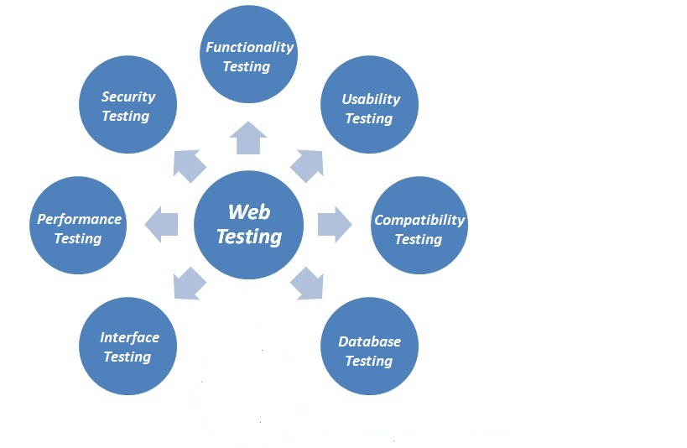

**1.**[**Functionality Testing**](http://www.softwaretestingclass.com/functional-testing/)**:**

In Functional testing we need check the each components are functioning as expected or not, so it is also called as “**Component Testing**”. Functional testing is to testing the functionality of the software application under test. Basically, it is to check the basic functionality mentioned in the functional specification document. Also check whether software application is meeting the user expectations. We can also say that checking the behavior of the software application against test specification.

In this testing activities should include:

**Link Testing:**

Check for all **broken links** on your web pages & all links are working correctly. Along with you can check the different links on you web pages:

* Internal links
* Outgoing links

**Web form testing:**

In the web application testing the “Forms Testing” is the essential part of testing any web site. The main purpose of Form is to get the information from user & store into the database. And keep on interact with them. Below are the test cases which should be considered while doing form testing:

* First thing to test in the form is the Validations on each form fields. Here two types of Validation need to be consider – “Client side” & “Server side” validations.
* Check default values are being populated
* Check for all Mandatory fields. Check if a user not entered a required field showing a mandatory error message.
* Add information using form & update information using form.
* Tab orders.
* Check for the default values of fields.
* Forms are optimally formatted for better readability
* In Negative testing enter invalid inputs to the forms fields.

**Test HTML and CSS:**

To optimize web site in the search engine then testing of HTML and CSS make important role. In this testing check that different search engines can crawl your site without any error. You should check for all Syntax Errors, Color Schemas in the readable, check for Standard Compliance and the standards are followed like W3C, ISO, ECMA, IETF, WS-I, OASIS.

**2. Usability testing:**

Now a day’s the Usability testing is playing an important role of any web application. This testing is to be carried out by testers like you to ensure that cover all possible test cases which targeted audience of the web application are doing regularly.

This would include –

Navigation testing of the web site:

* All possible options like Menus, Links or buttons on web pages should be visible & accessible from all the web pages.
* Web pages navigation should be Easy to use
* Help instruction content should be clear & should satisfy the purpose.
* All options on header, footer & left/right navigation should be consistent throughout the pages.

Content testing of the web site:

* No spelling or grammatical errors mistake in content throughout the page.
* Alt text should be present on Images
* No broken images
* Your task is to validate all for UI testing
* Follow some standard on content building on web page
* All content should be legible & easy to understand.
* Dark color infuriates the users, so avoid using dark colors in the theme.
* Proper size images should be placed on web page
* All the anchor text links should be working properly.

**3. Compatibility testing.**

In software application testing the Compatibility testing is the non-functional part of testing. It is ensuring that how application’s working in the supported environments. Customers are uses web application on different Operating systems, Browser compatibility, computing capacity of Hardware Platform, Databases and Bandwidth handling capacity of networking hardware. The Compatibility testing is to make sure that “Is web application show correctly across different devices?”

This would include-

**Browser Compatibility Test:**

Web applications are rendering differently on different browsers. The objective of browser compatibility testing is to ensure that no any errors on the different web browsers while rendering the sites. In Browser Compatibility Testing you need to ensure that your web application is being displayed properly on different browsers. Also check AJAX, JavaScript and authentication are functioning correctly.

**OS compatibility:**

In new technology newer graphics designs are used & different APIs are used which may not work on different Operating systems. Also on rendering of different objects like text fields, buttons may display different on different Operating System. So testing of web application should be carried out on different OS like Windows, MAC, Solaris, Unix, Linux with different OS flavors.

**4. Database Testing:**

Data reliability is key part in the Database testing. So for web application should be thoroughly tested.

Testing activities would include-

* Check if queries are executed without any errors.
* Creating, updating or deleting data in database should maintain the data integrity.
* More time should not take to execute the queries, if required tune the queries for better performance.
* Check load on database while executing heavier queries & check the result.
* Collect data from database & represent on the web pages correctly.

**5. Interface Testing:**

In the Interface testing mainly three areas should be covered: Web Server, Application Server and Database Server. Ensure that all the communications between these all servers should be carried out correctly. Verify that if connection between any servers is reset or lost then what is happing. Check if any request interrupts in-between then how application is responding. On returns of any error from web server or database server to application server then error should be Errors are handled properly & display such errors to the user.

* Web Server: Check if all web requests are accepting and not any requests are denied or leakages.
* Application Server: Check if request is sending correctly to the any server & displayed correctly. Check if errors are catch properly & displayed to admin user.
* Database Server: Check if database server is returns correct result on query request.

Check if all three servers are connected to each & test request is processing correctly. And any error in between then error should be displayed to user.

**6. Performance Testing:**

Performance testing is to check the web application is working under the heavy load. Performance testing is categorized into two parts:  
Web Stress Testing, Web Load Testing

This would include-

* Check if response times of Website application under different speeds of connections
* Check if site handles many simultaneous user requests at same time.
* Check if how your web application sustain under the peak loads
* Check if how the web site pulls through if crash occurs due to peak load.
* Check if optimization methods such as reduce load times by enabling cache on browser client and server side, gzip compression etc
* Check if any hardware memory leakage errors

**7. Security testing:**

The security testing is carried out to ensure that is any information leakage in terms of encrypting the data. In e-commerce website the Security testing is play an important role. In this testing check if secure information is to check whether how to store sensitive information such as credit cards etc.

Testing Activities will include-

* Check if unauthorized access to secure pages, if user changes from “https” to “http” (secure to non-secure) in secure pages then proper message should be display and vice versa.

**SCREENSHOT**

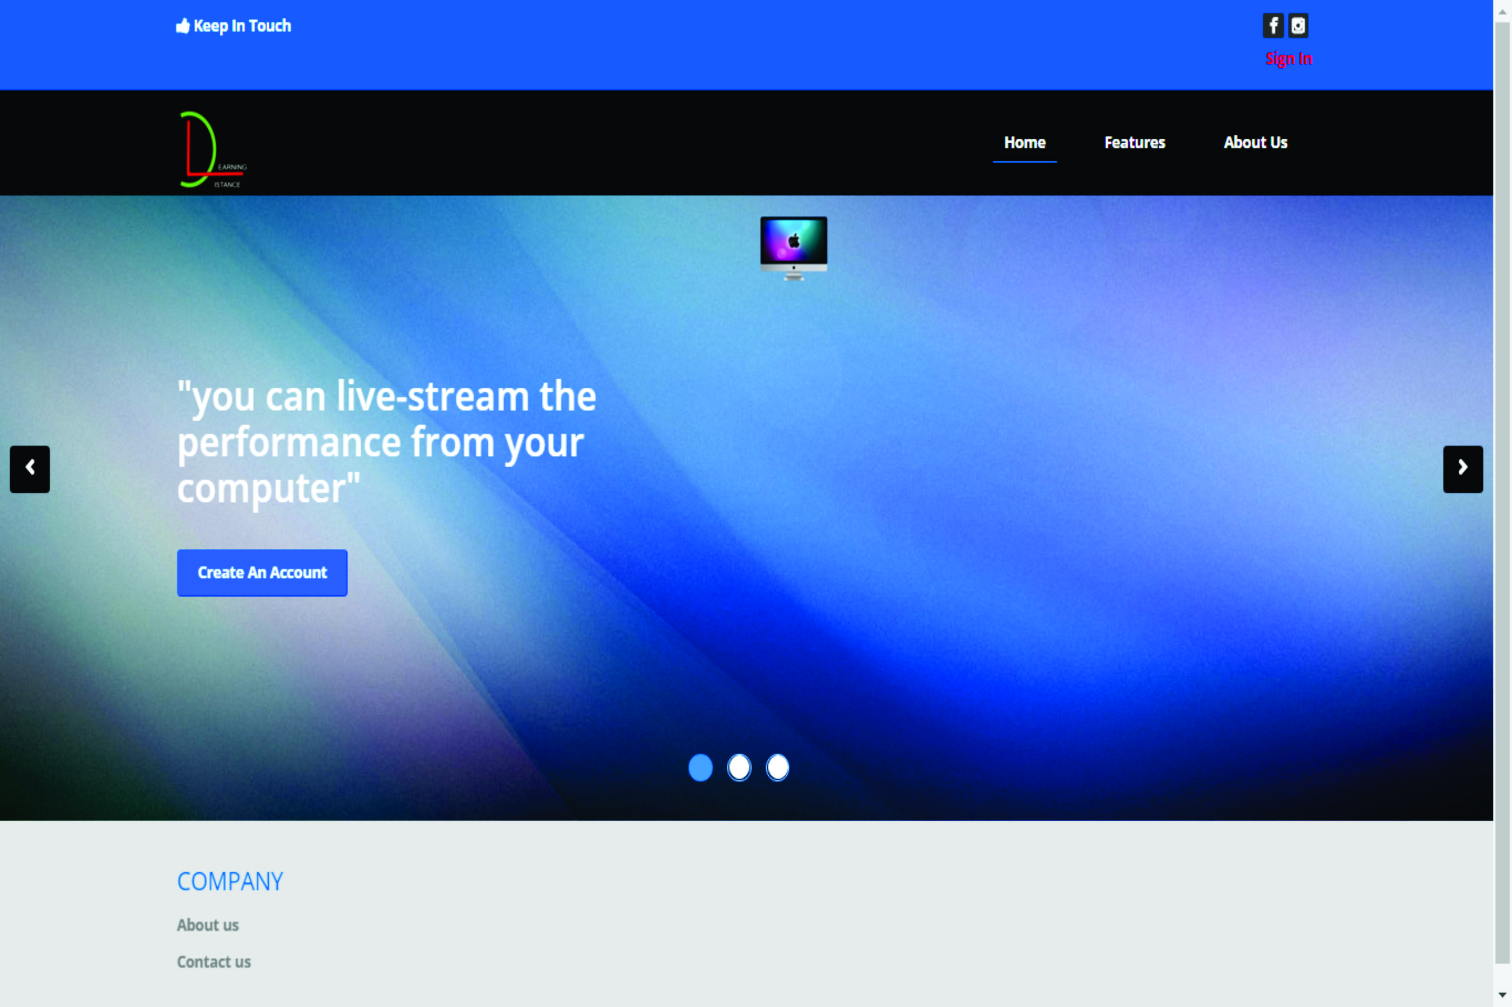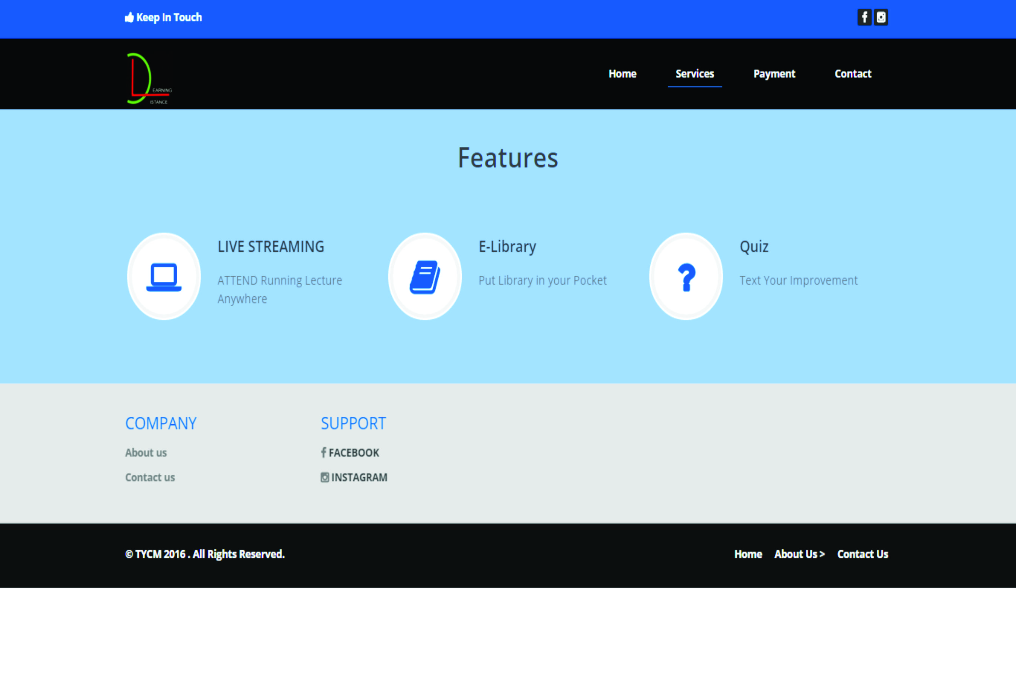

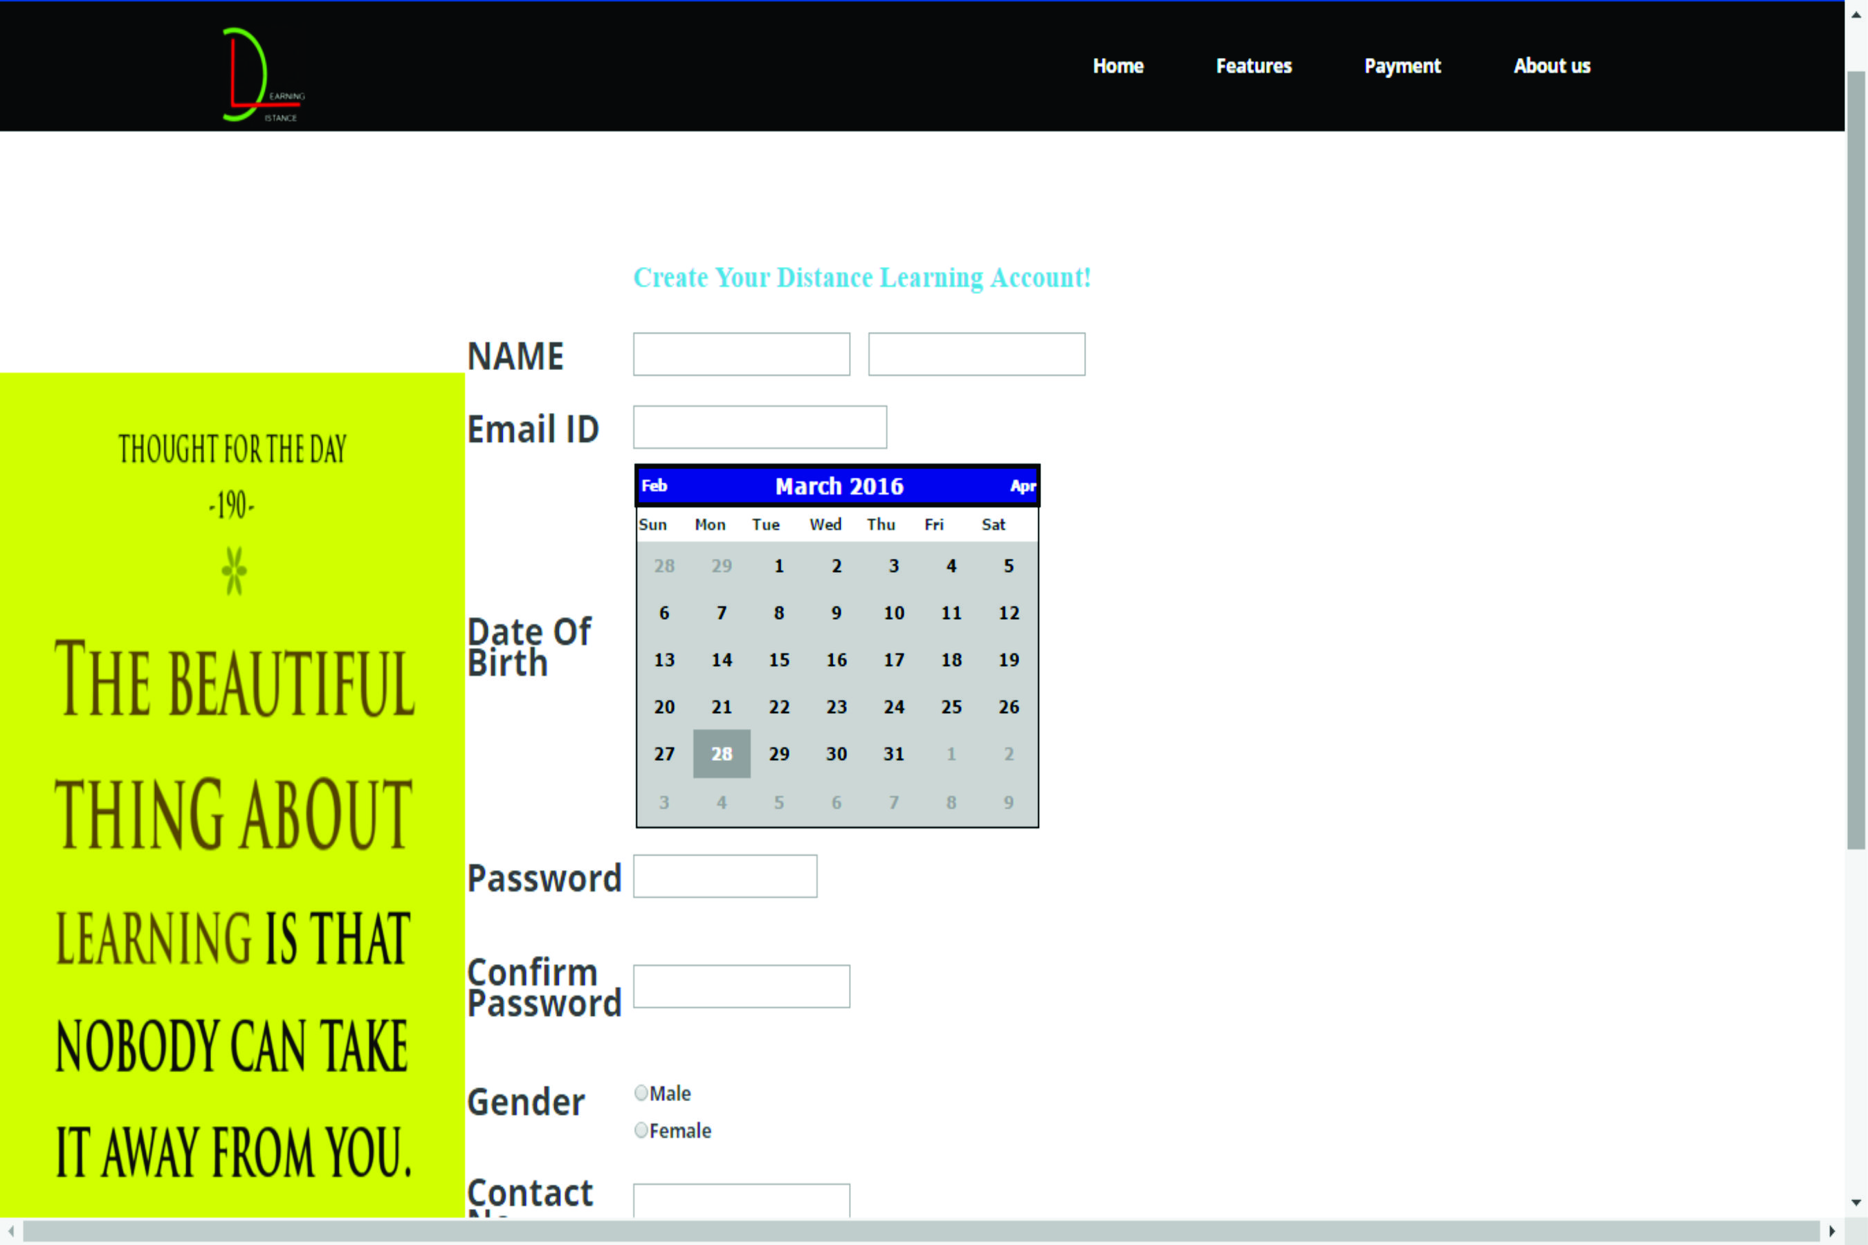

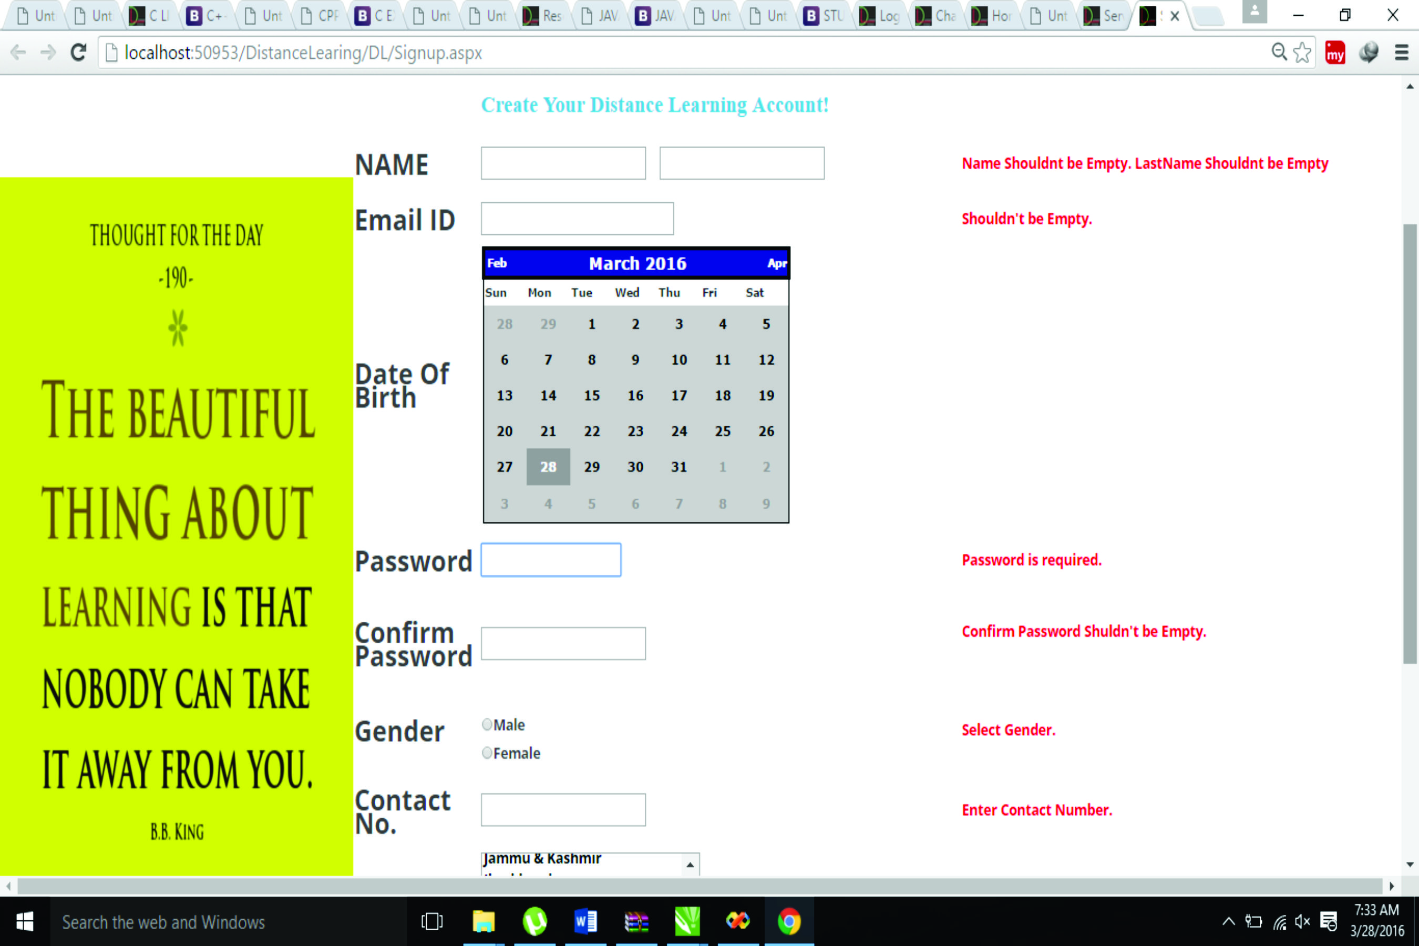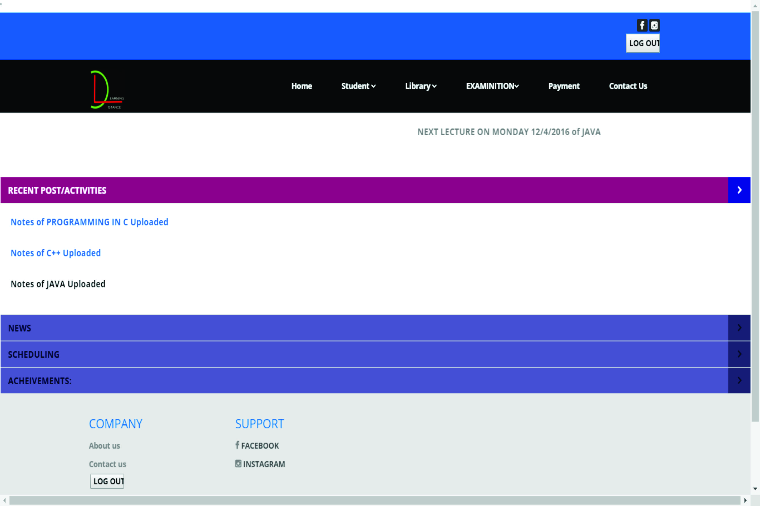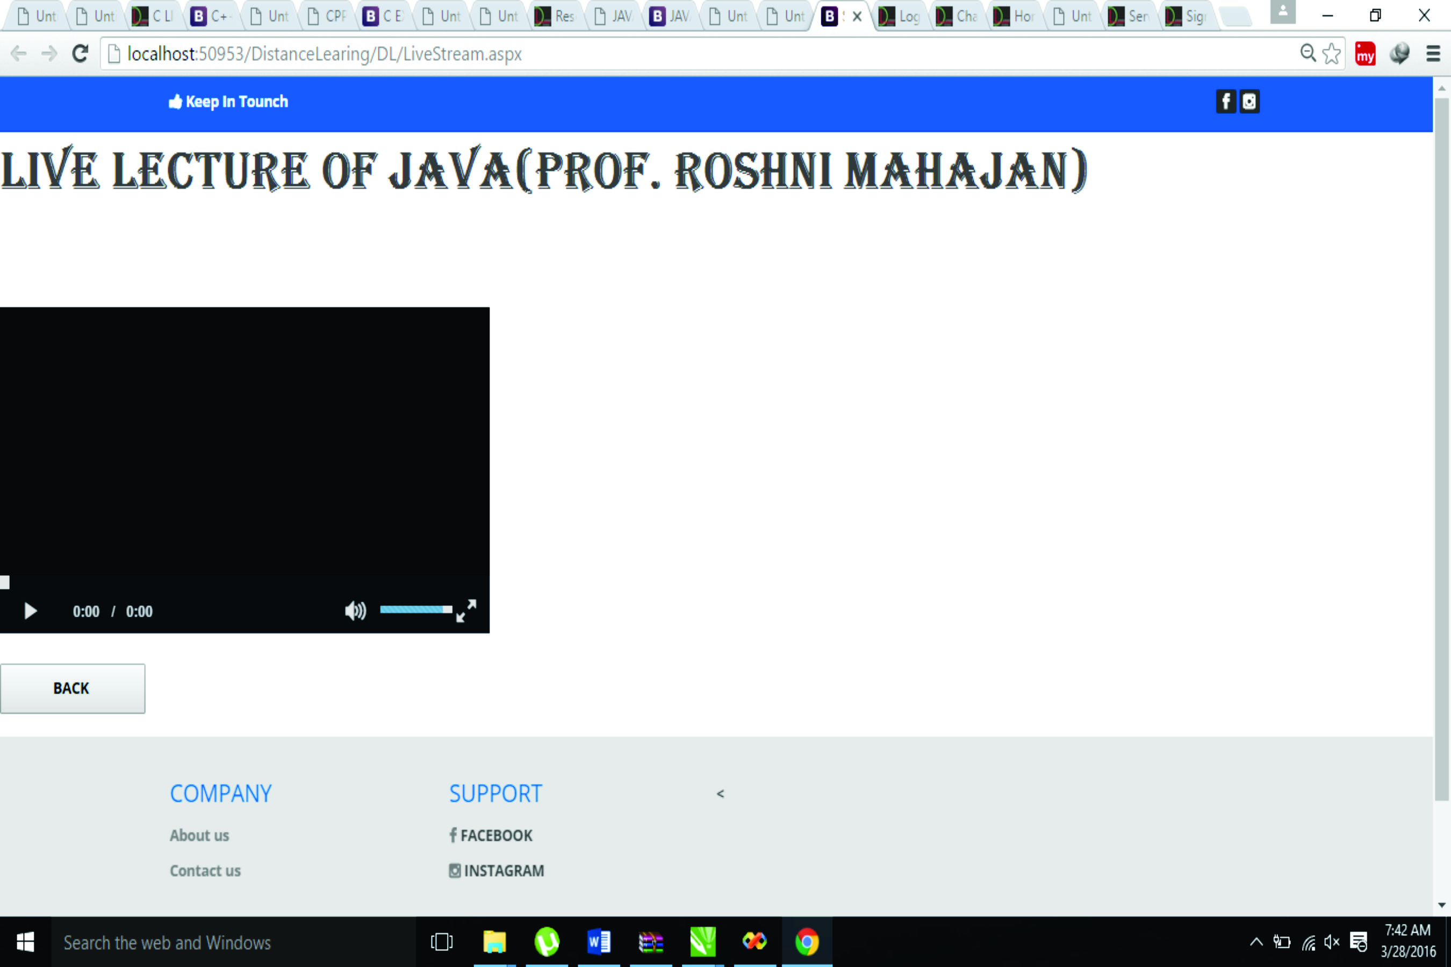

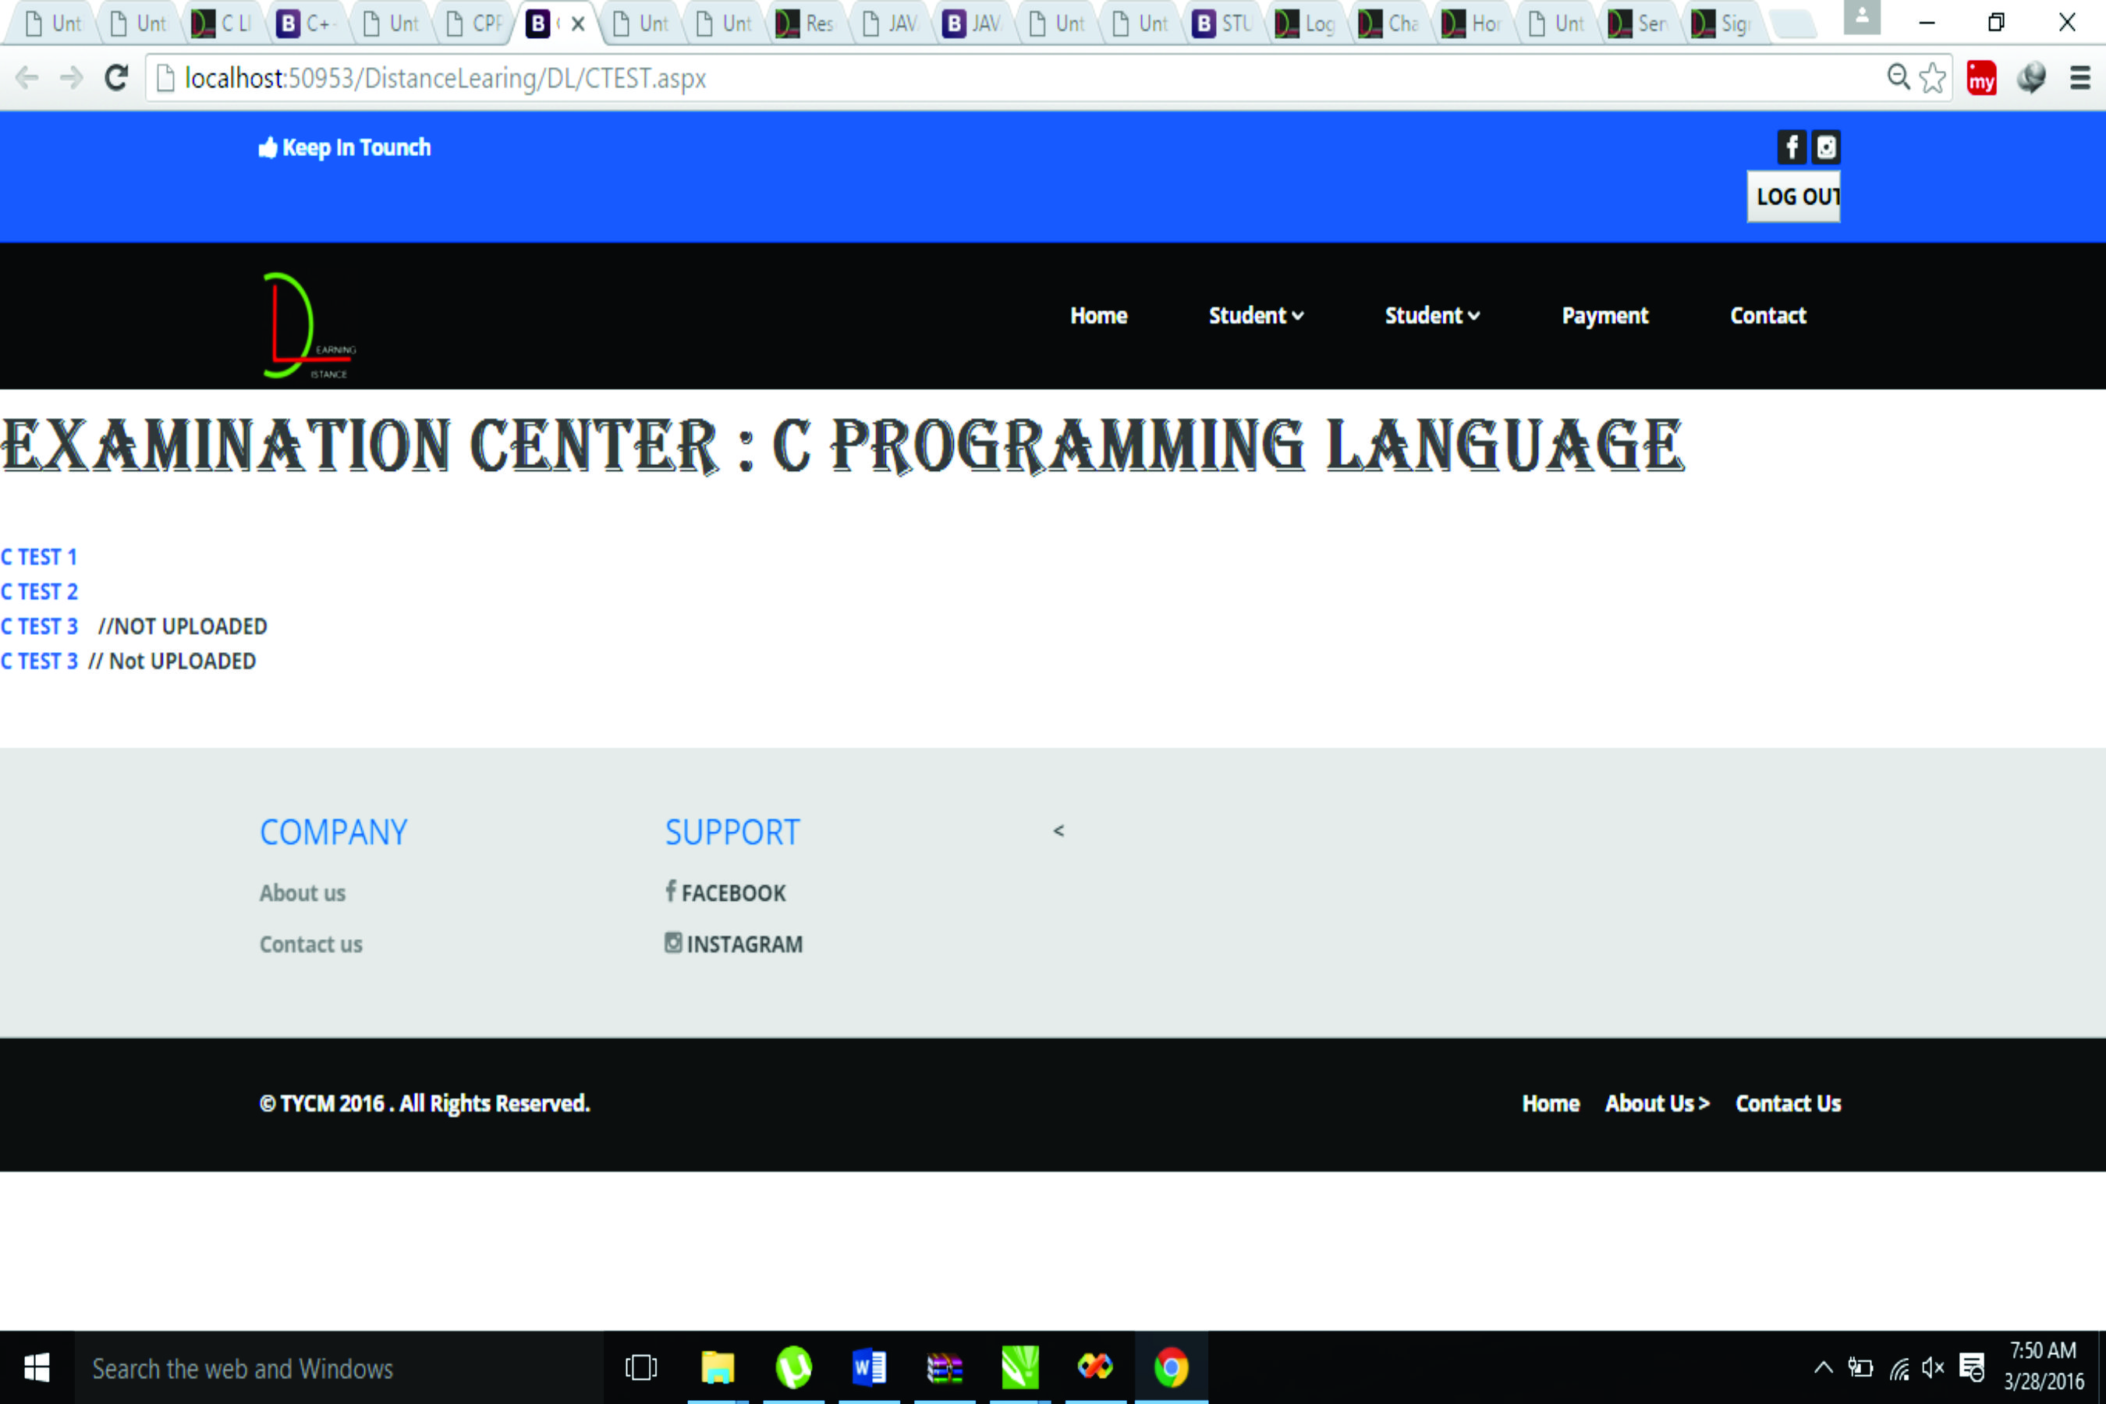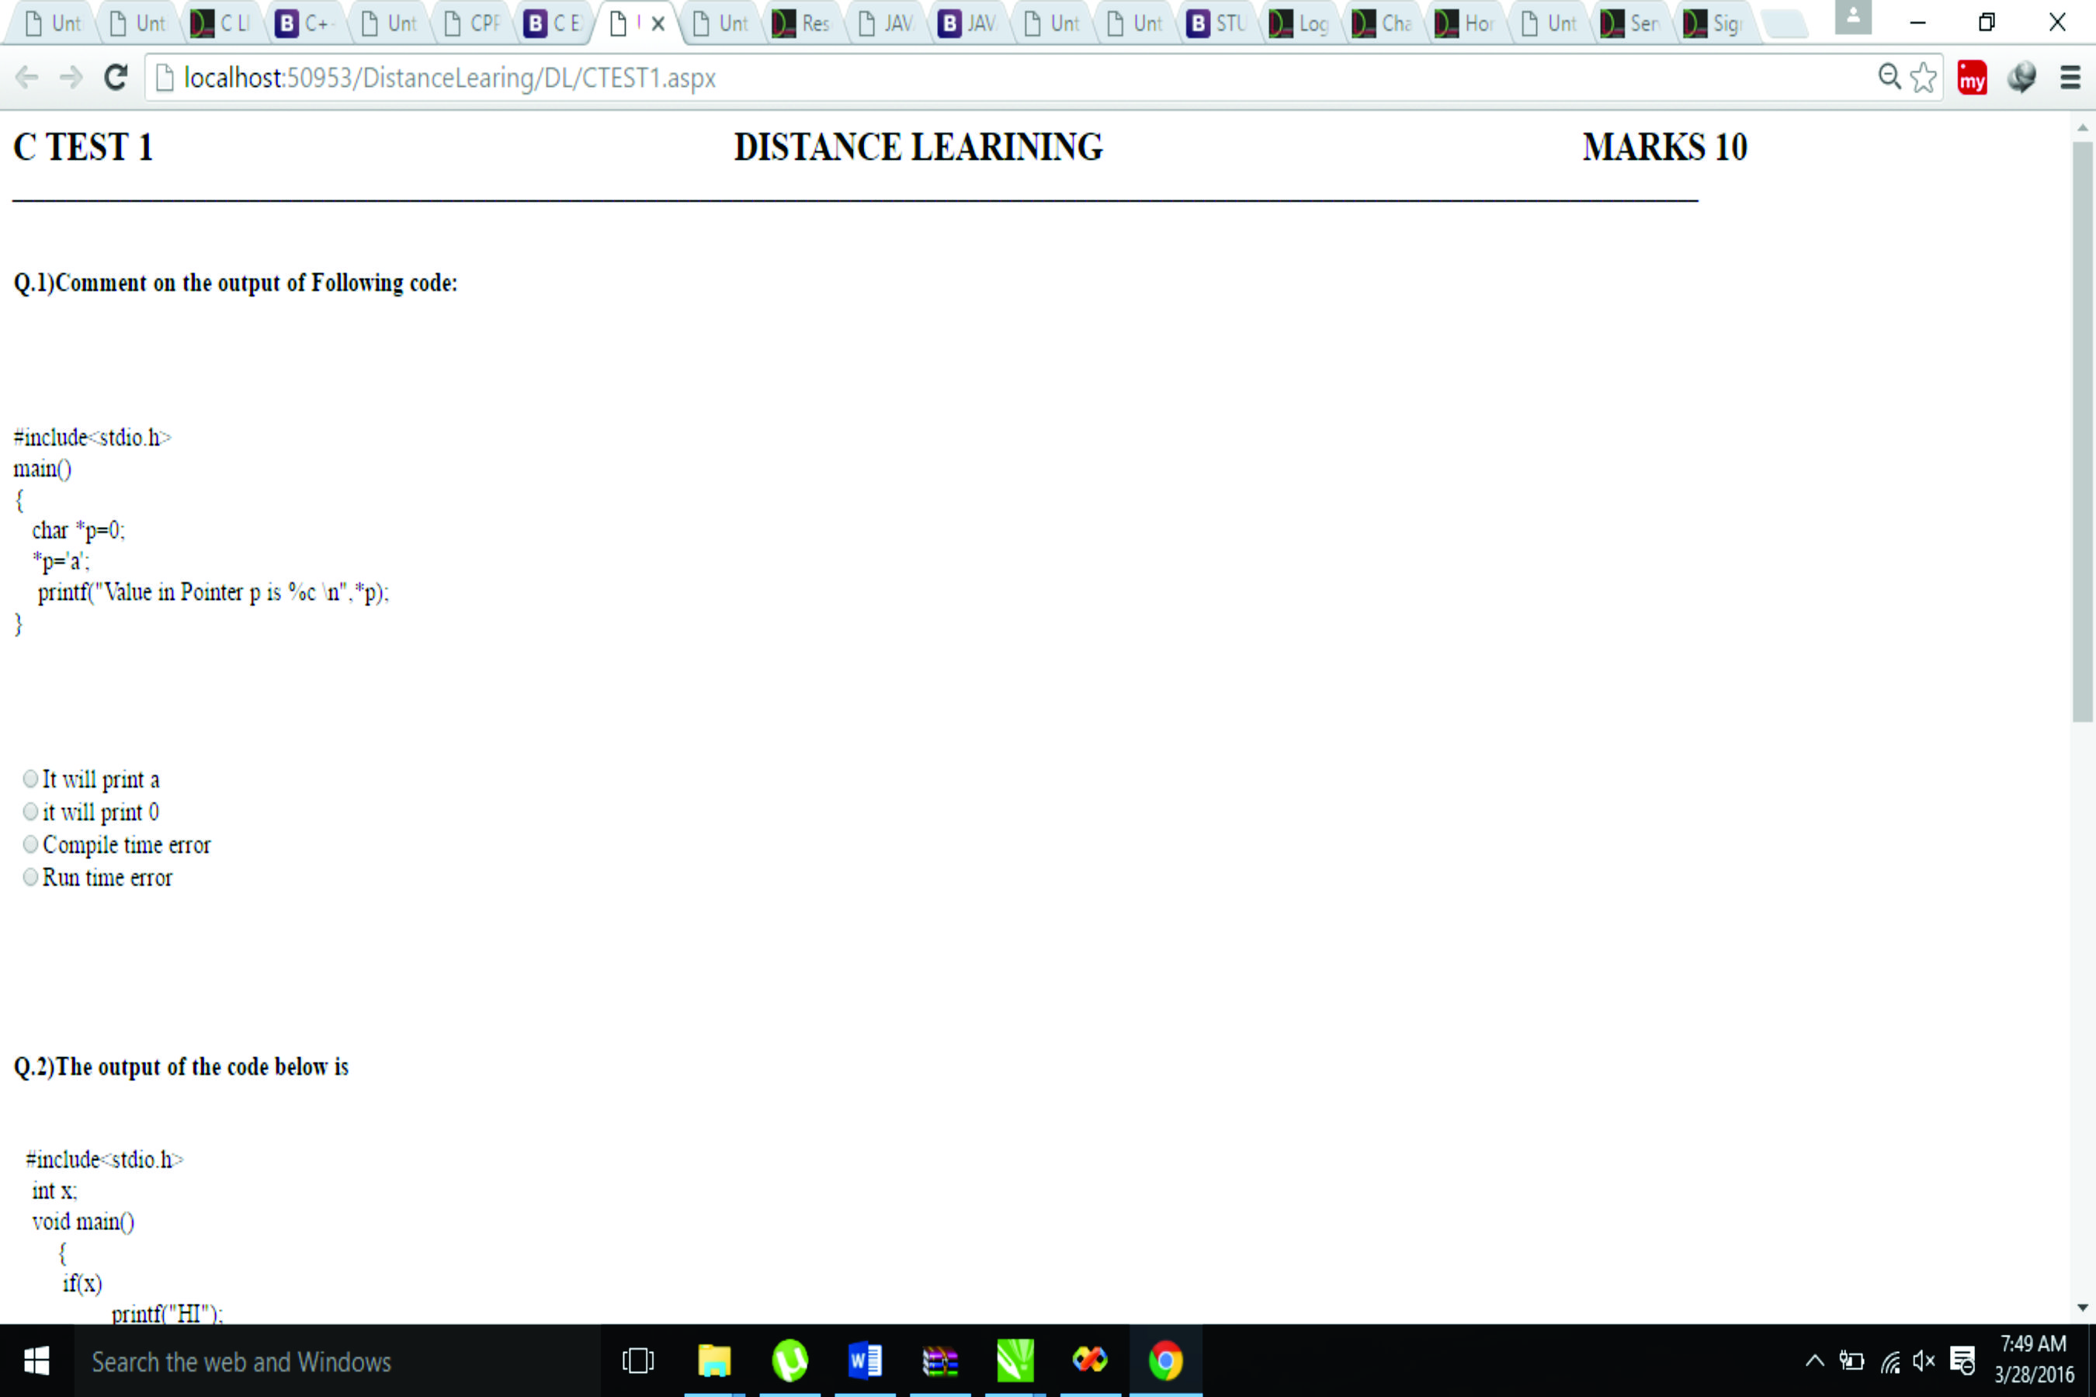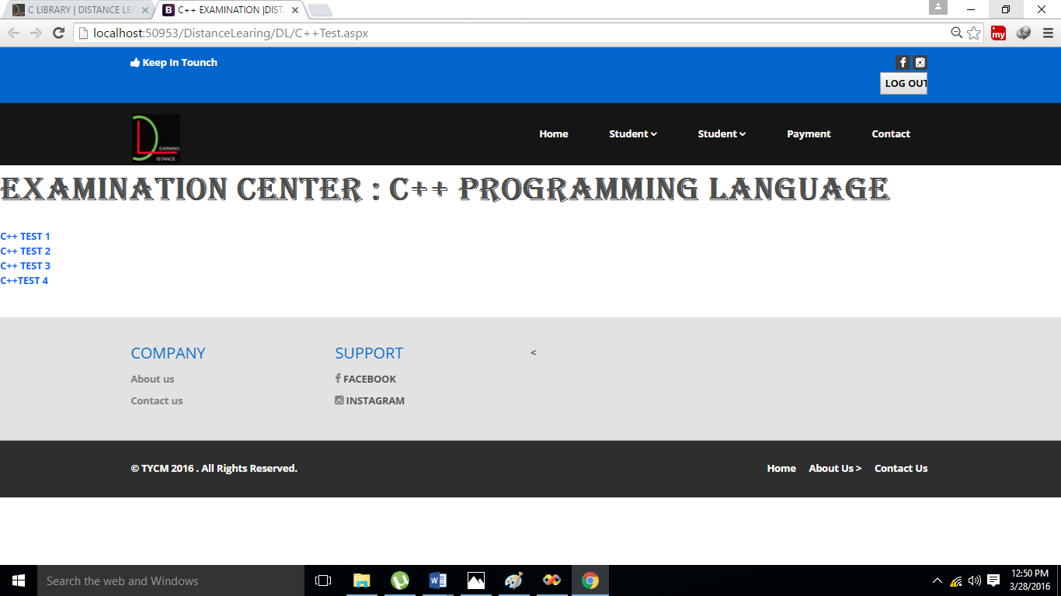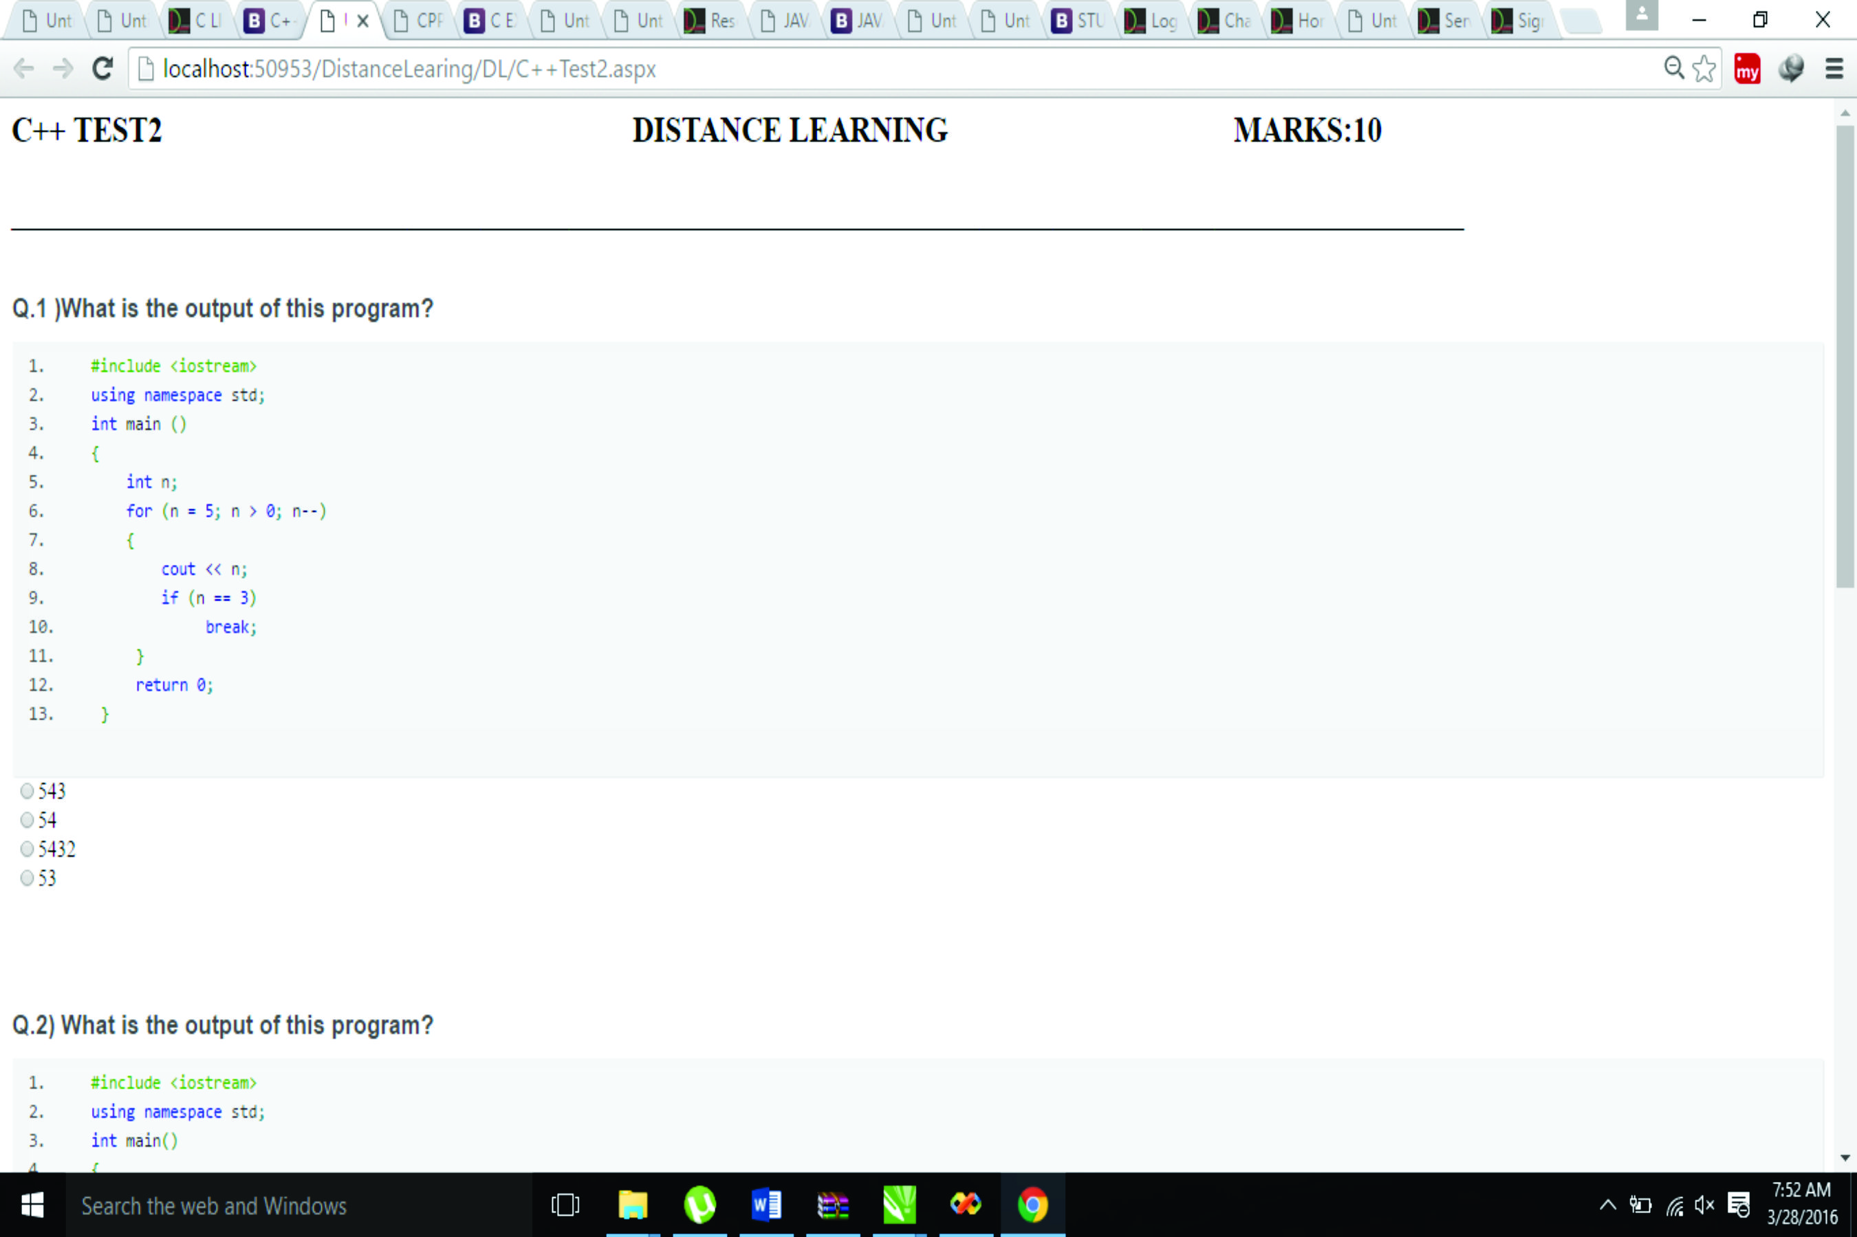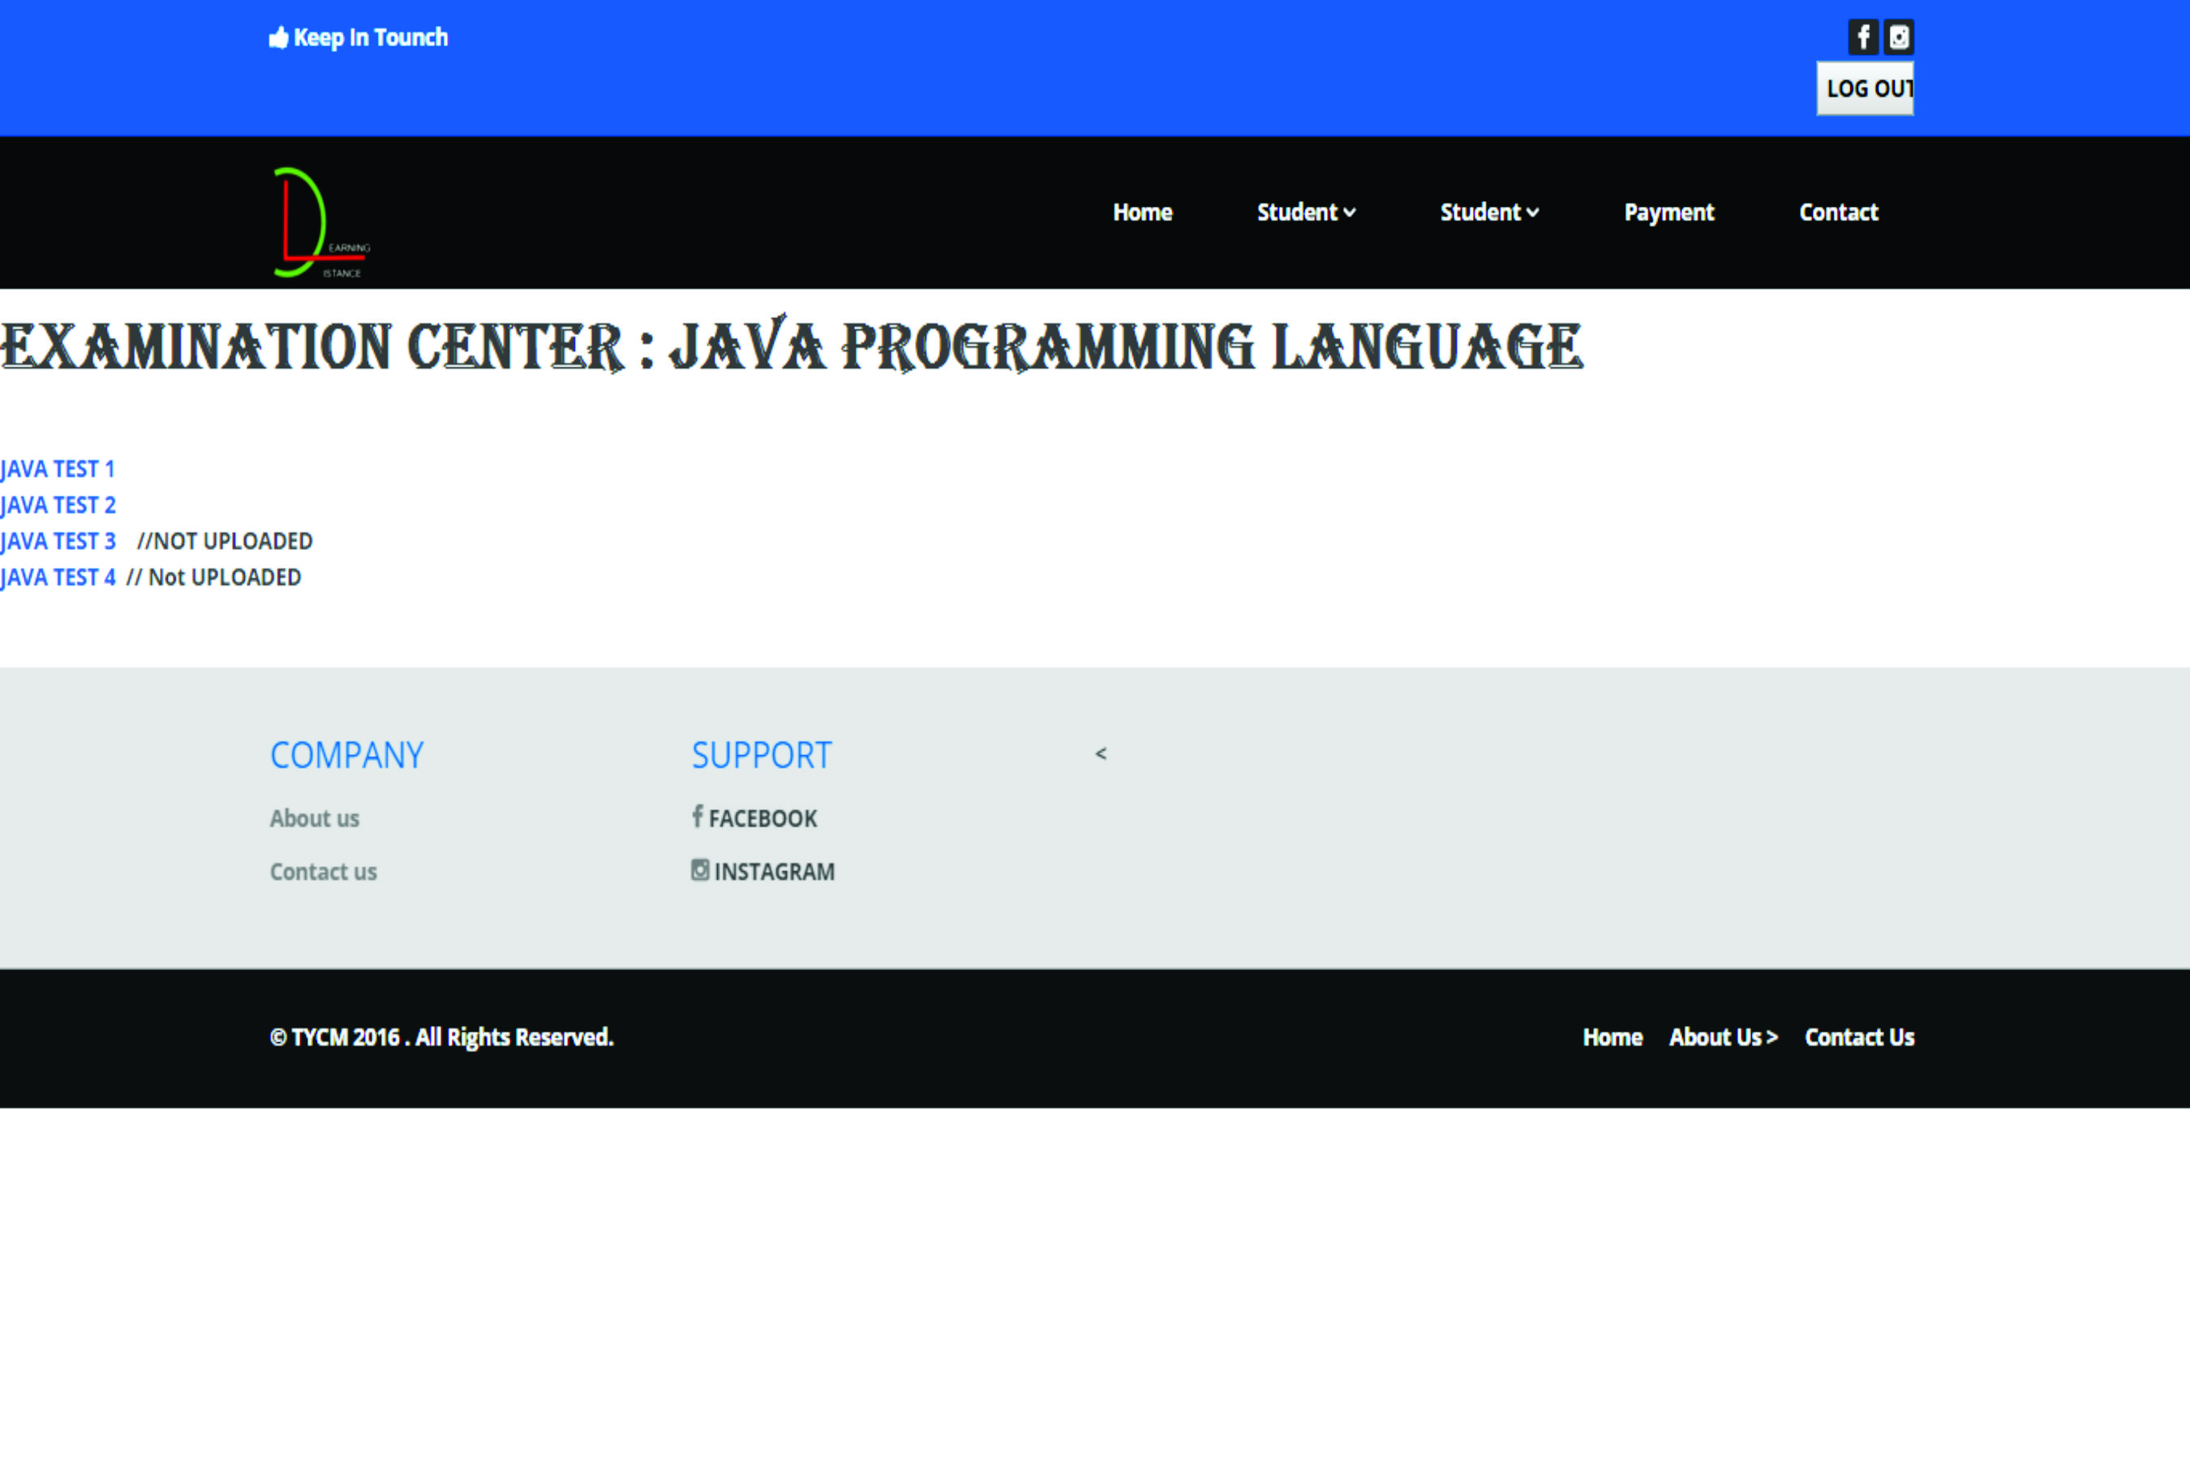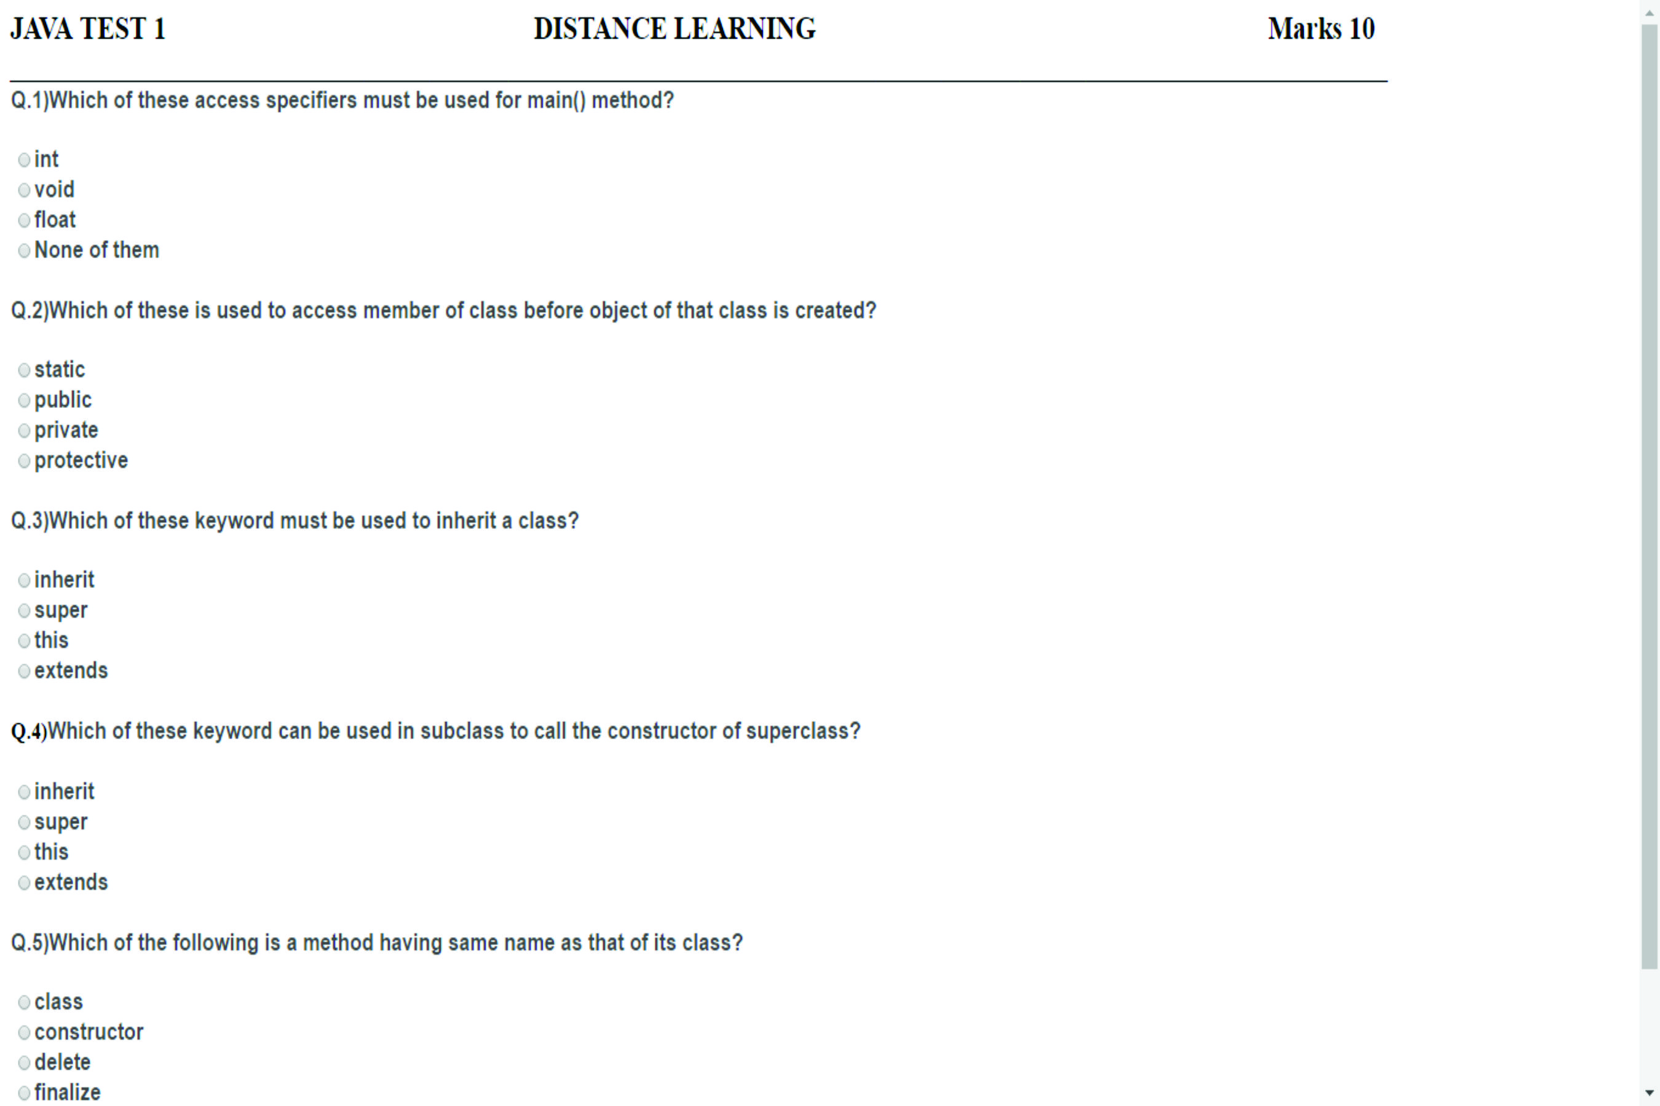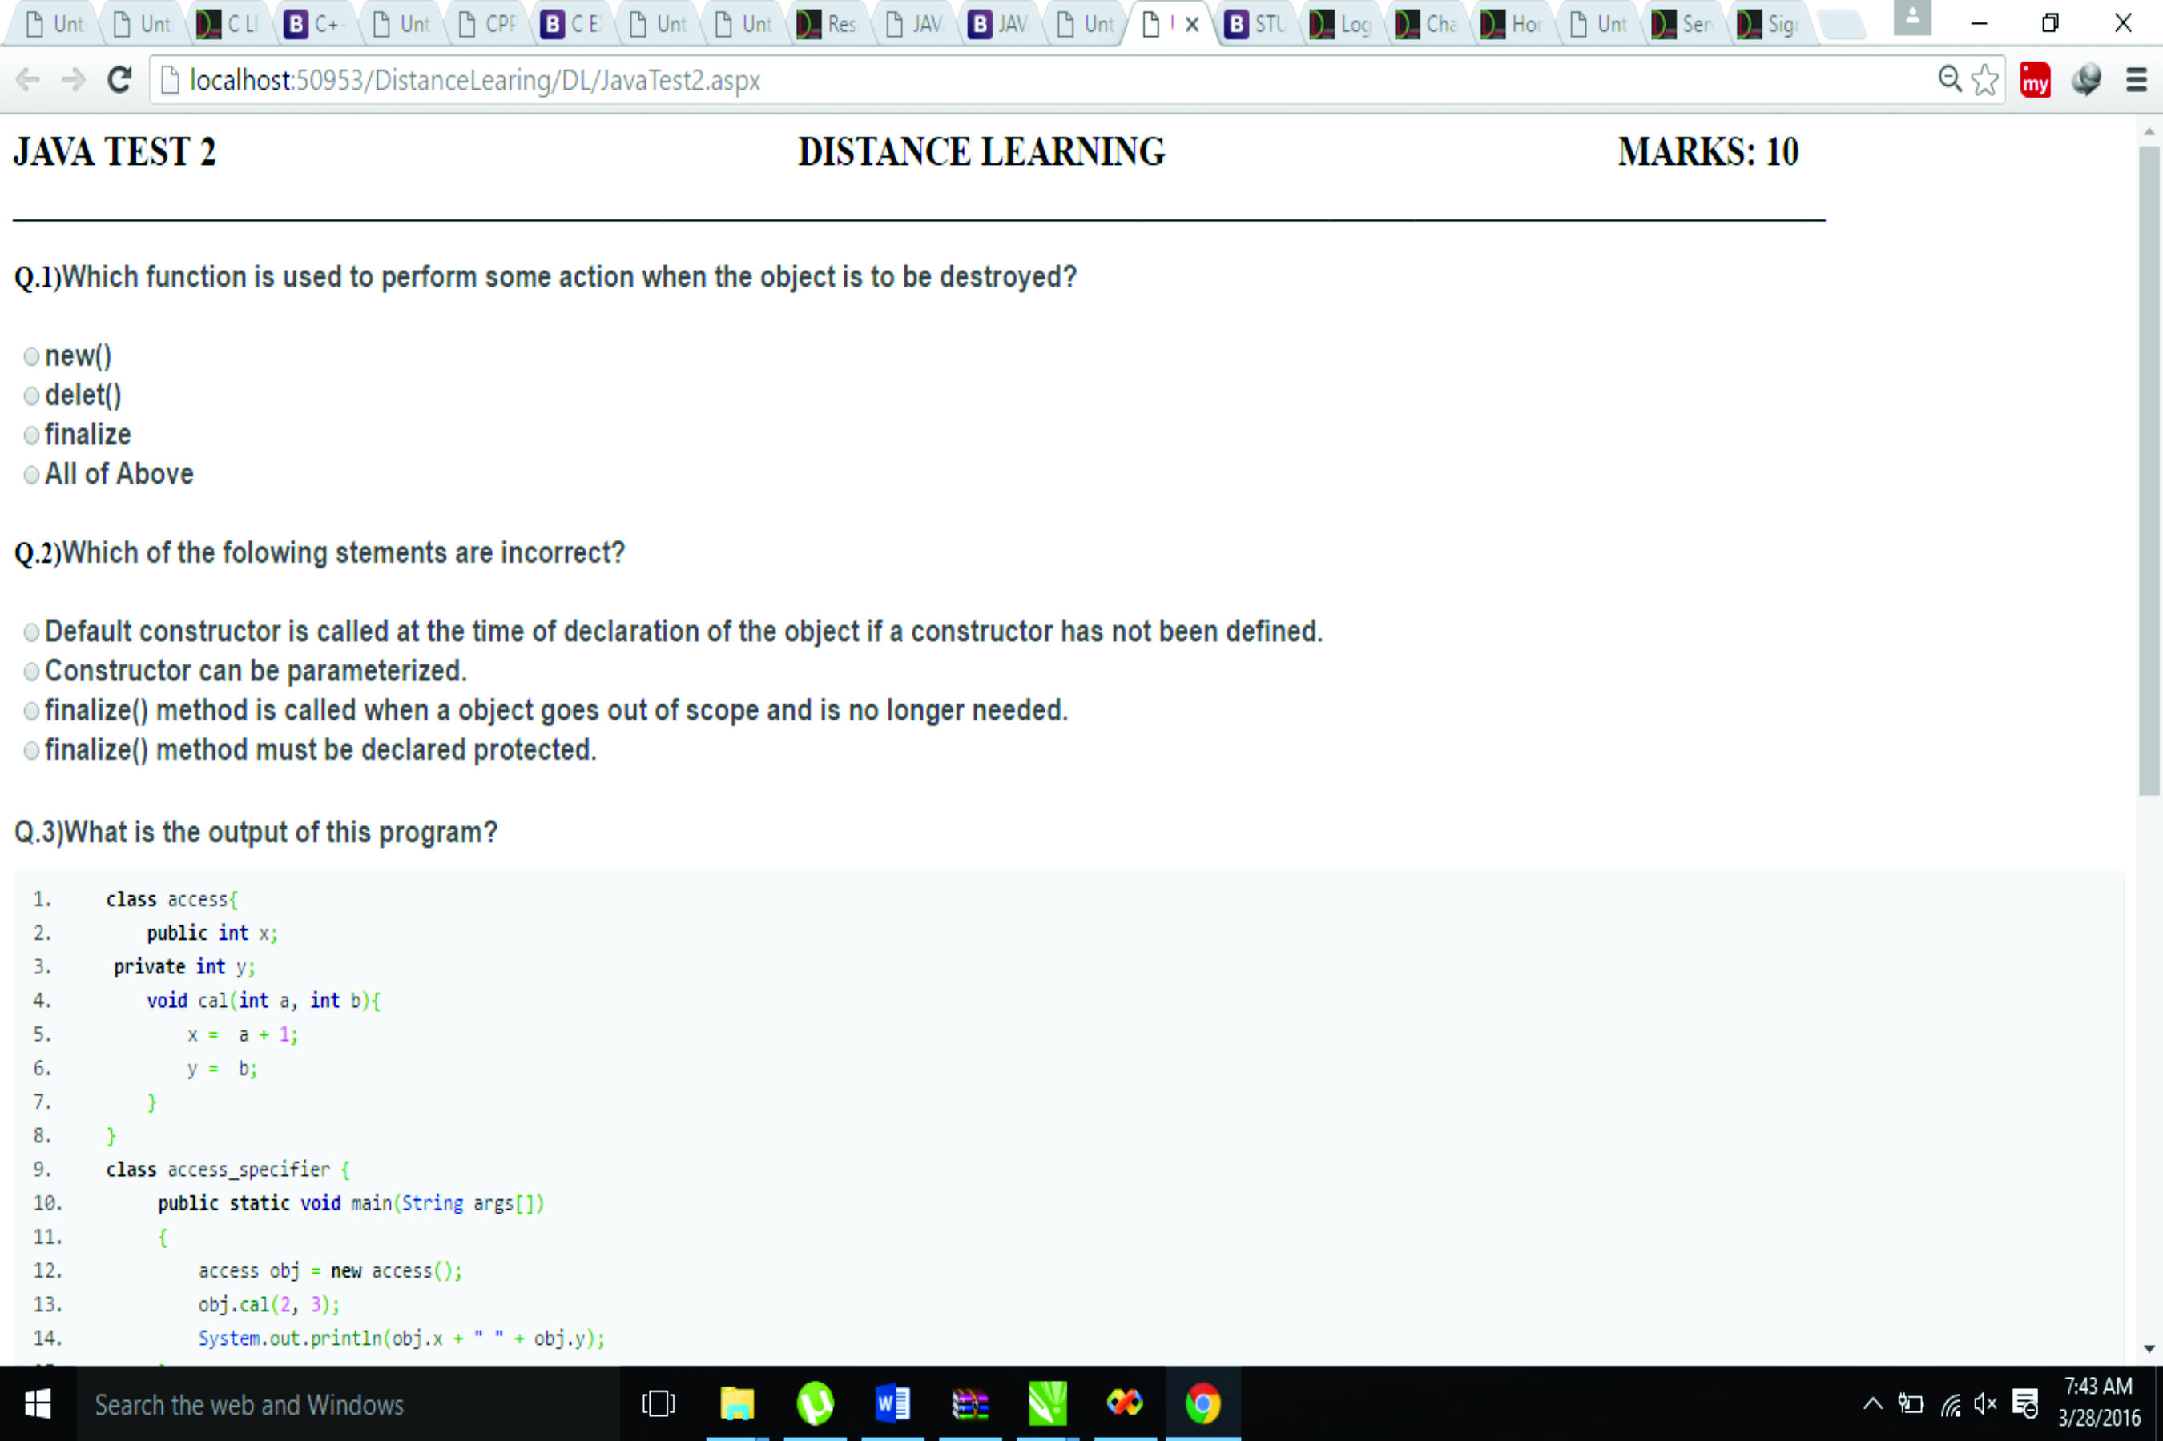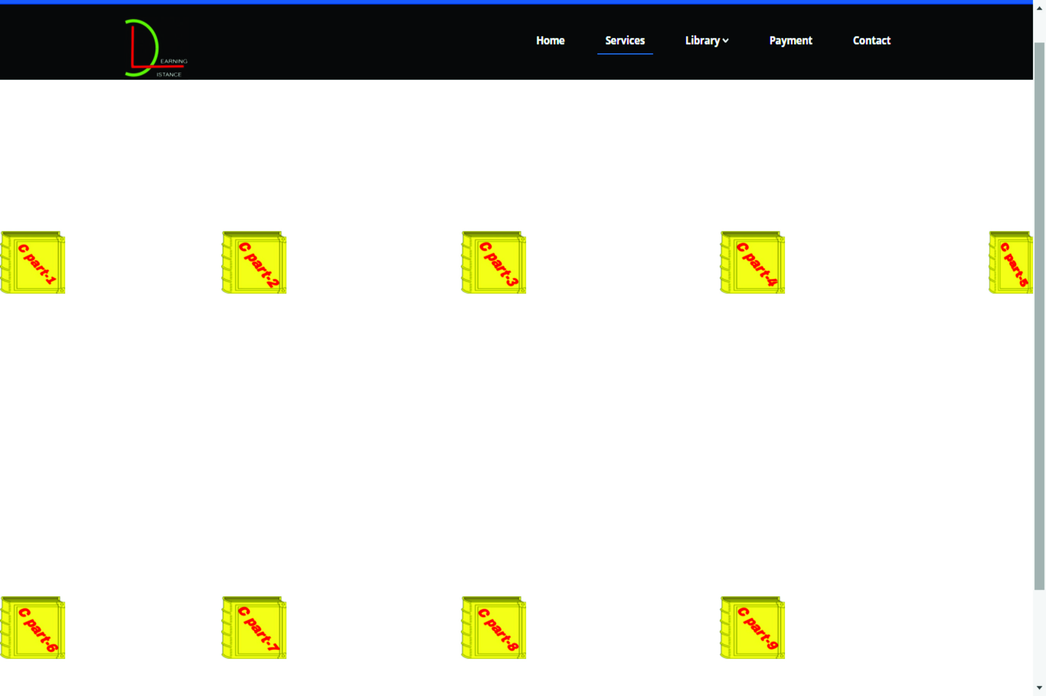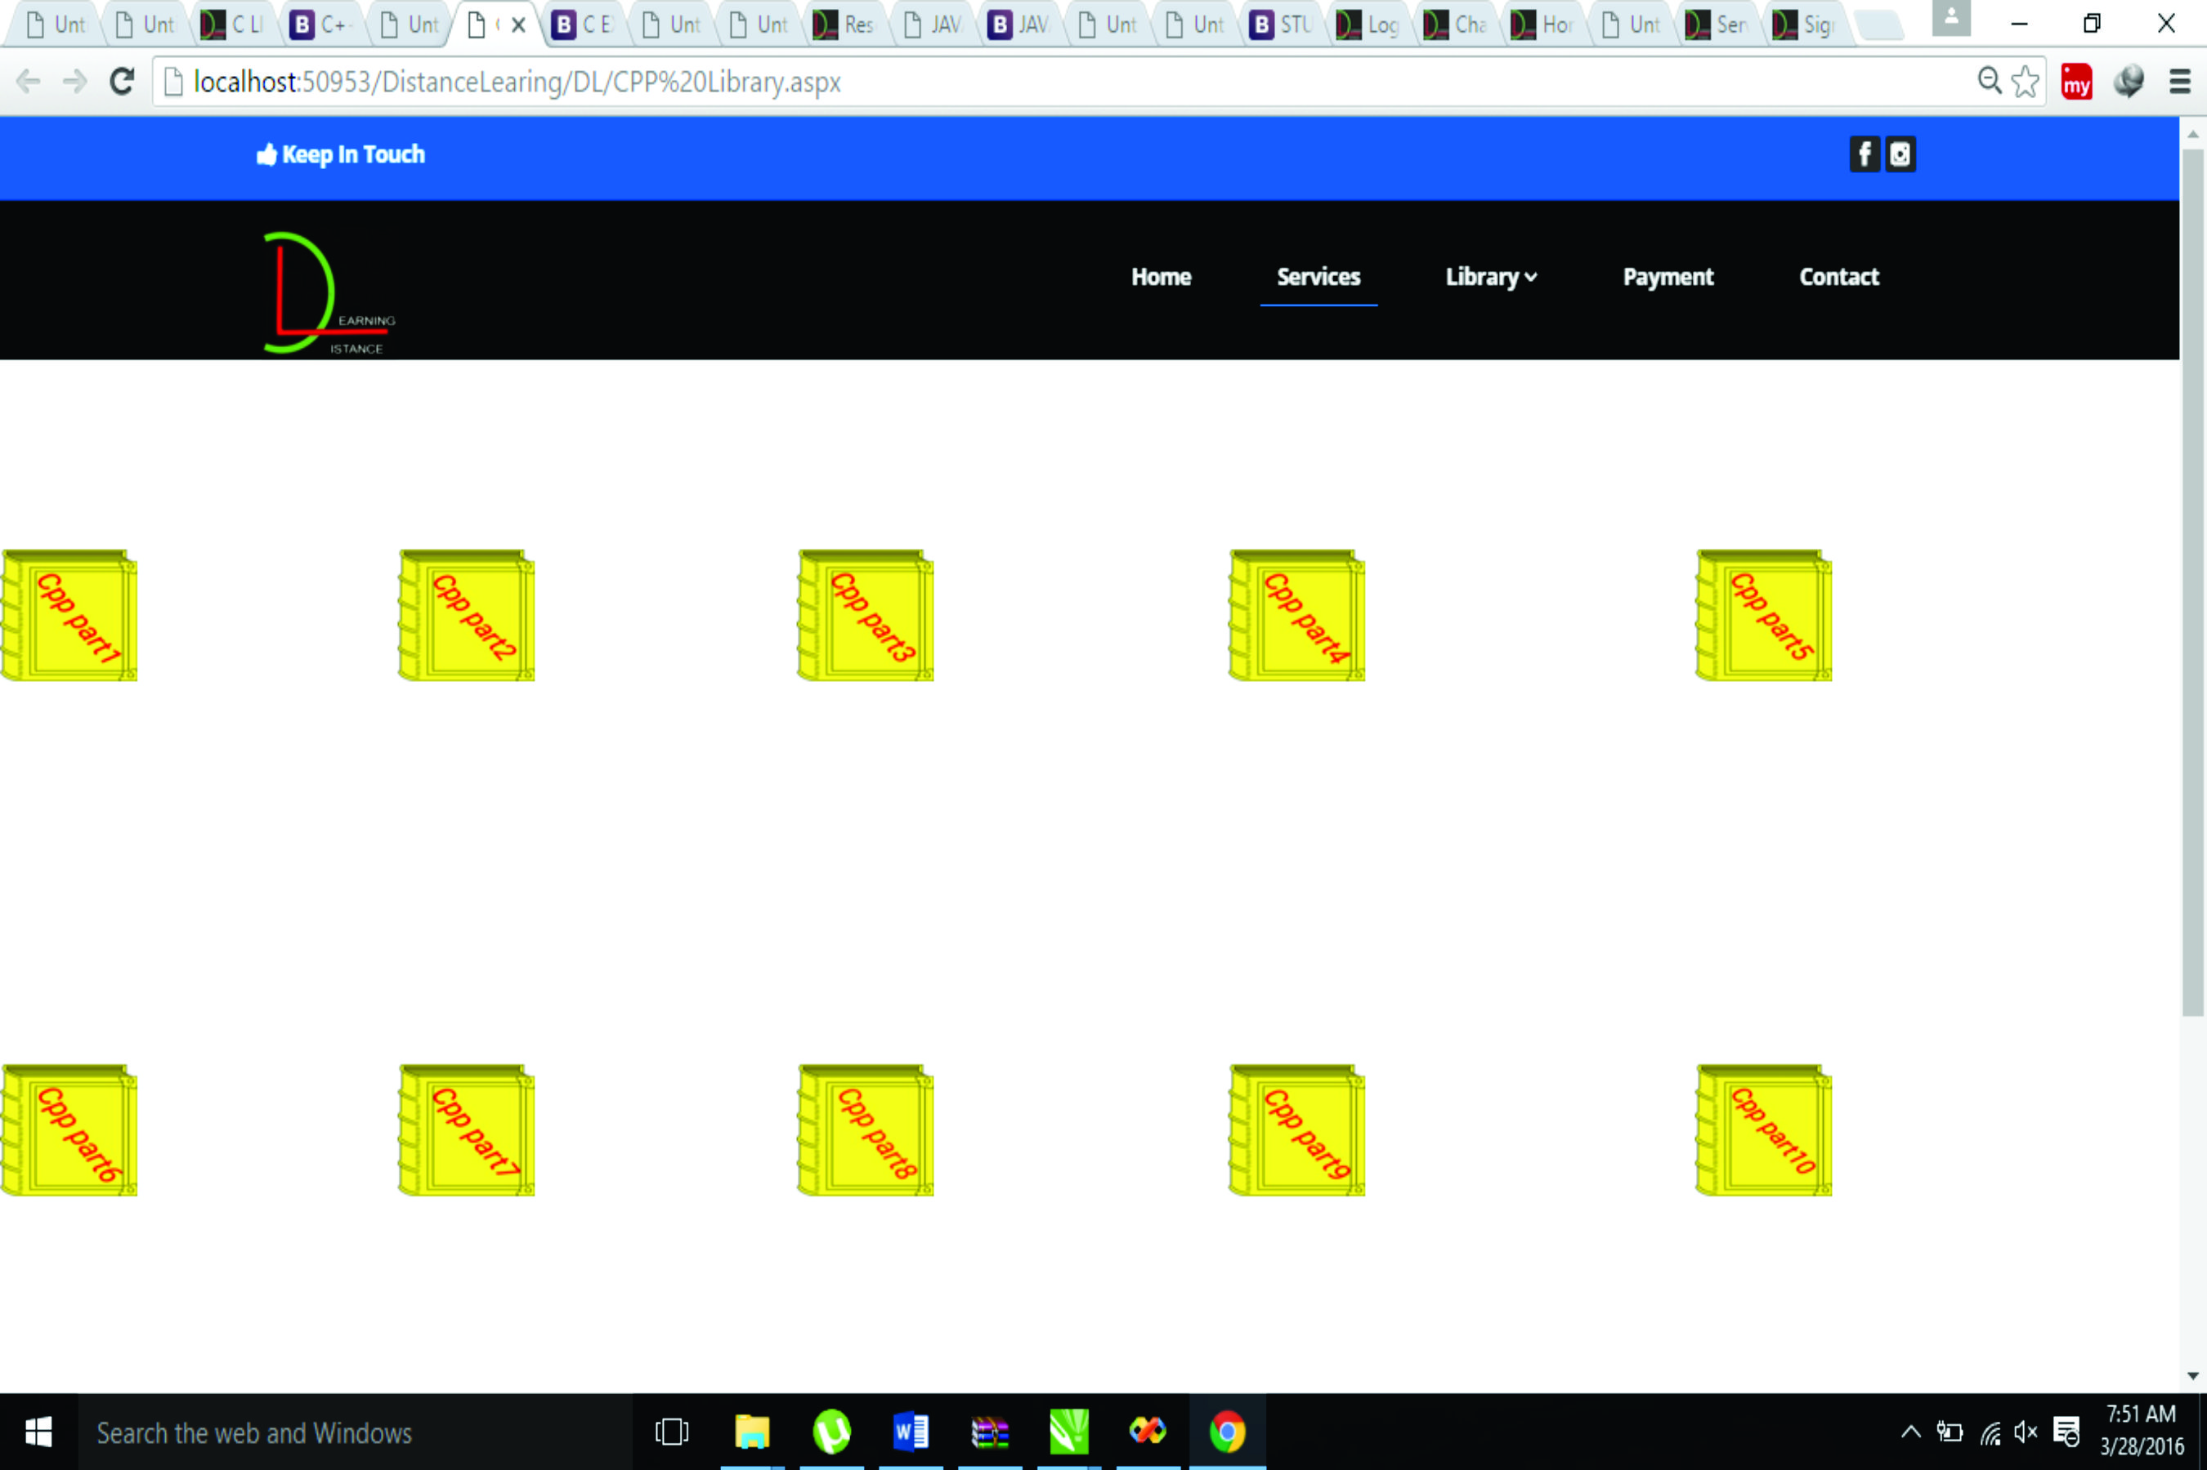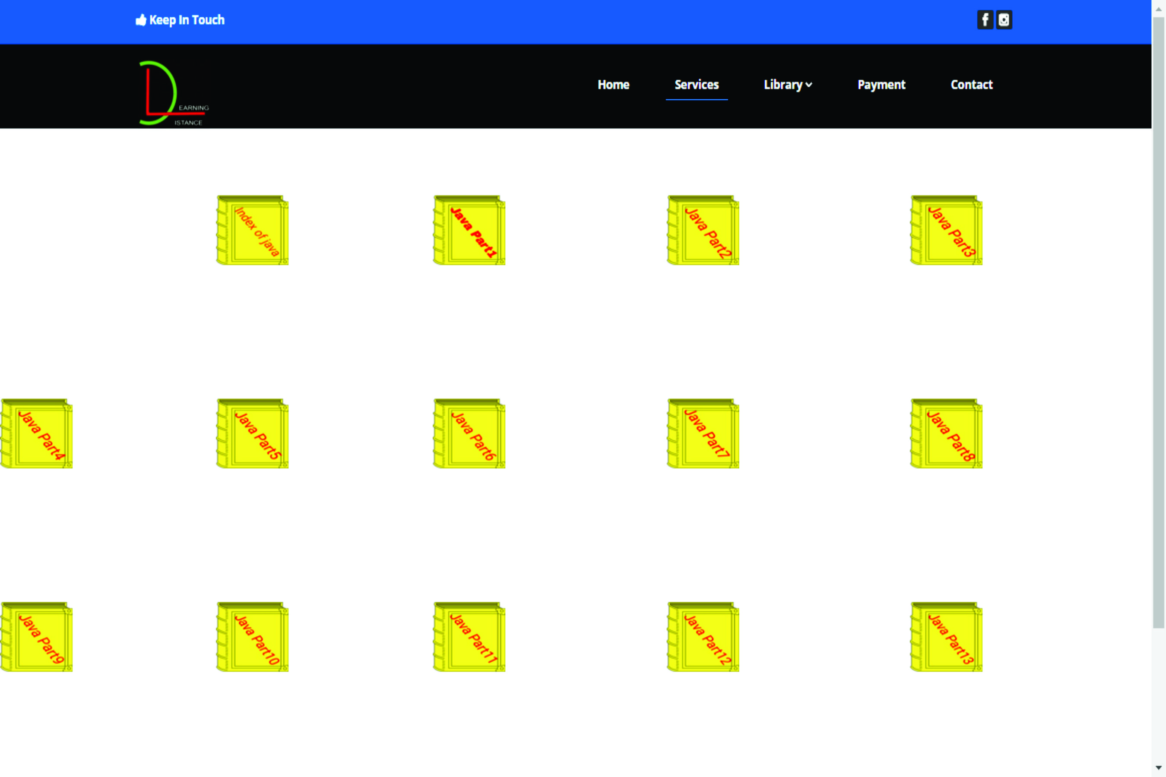

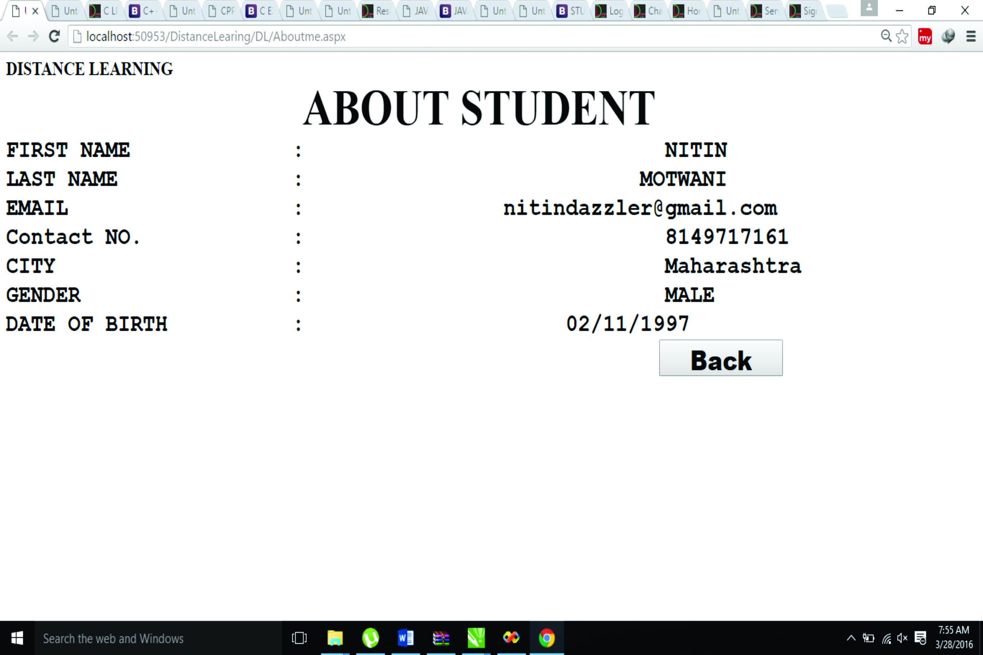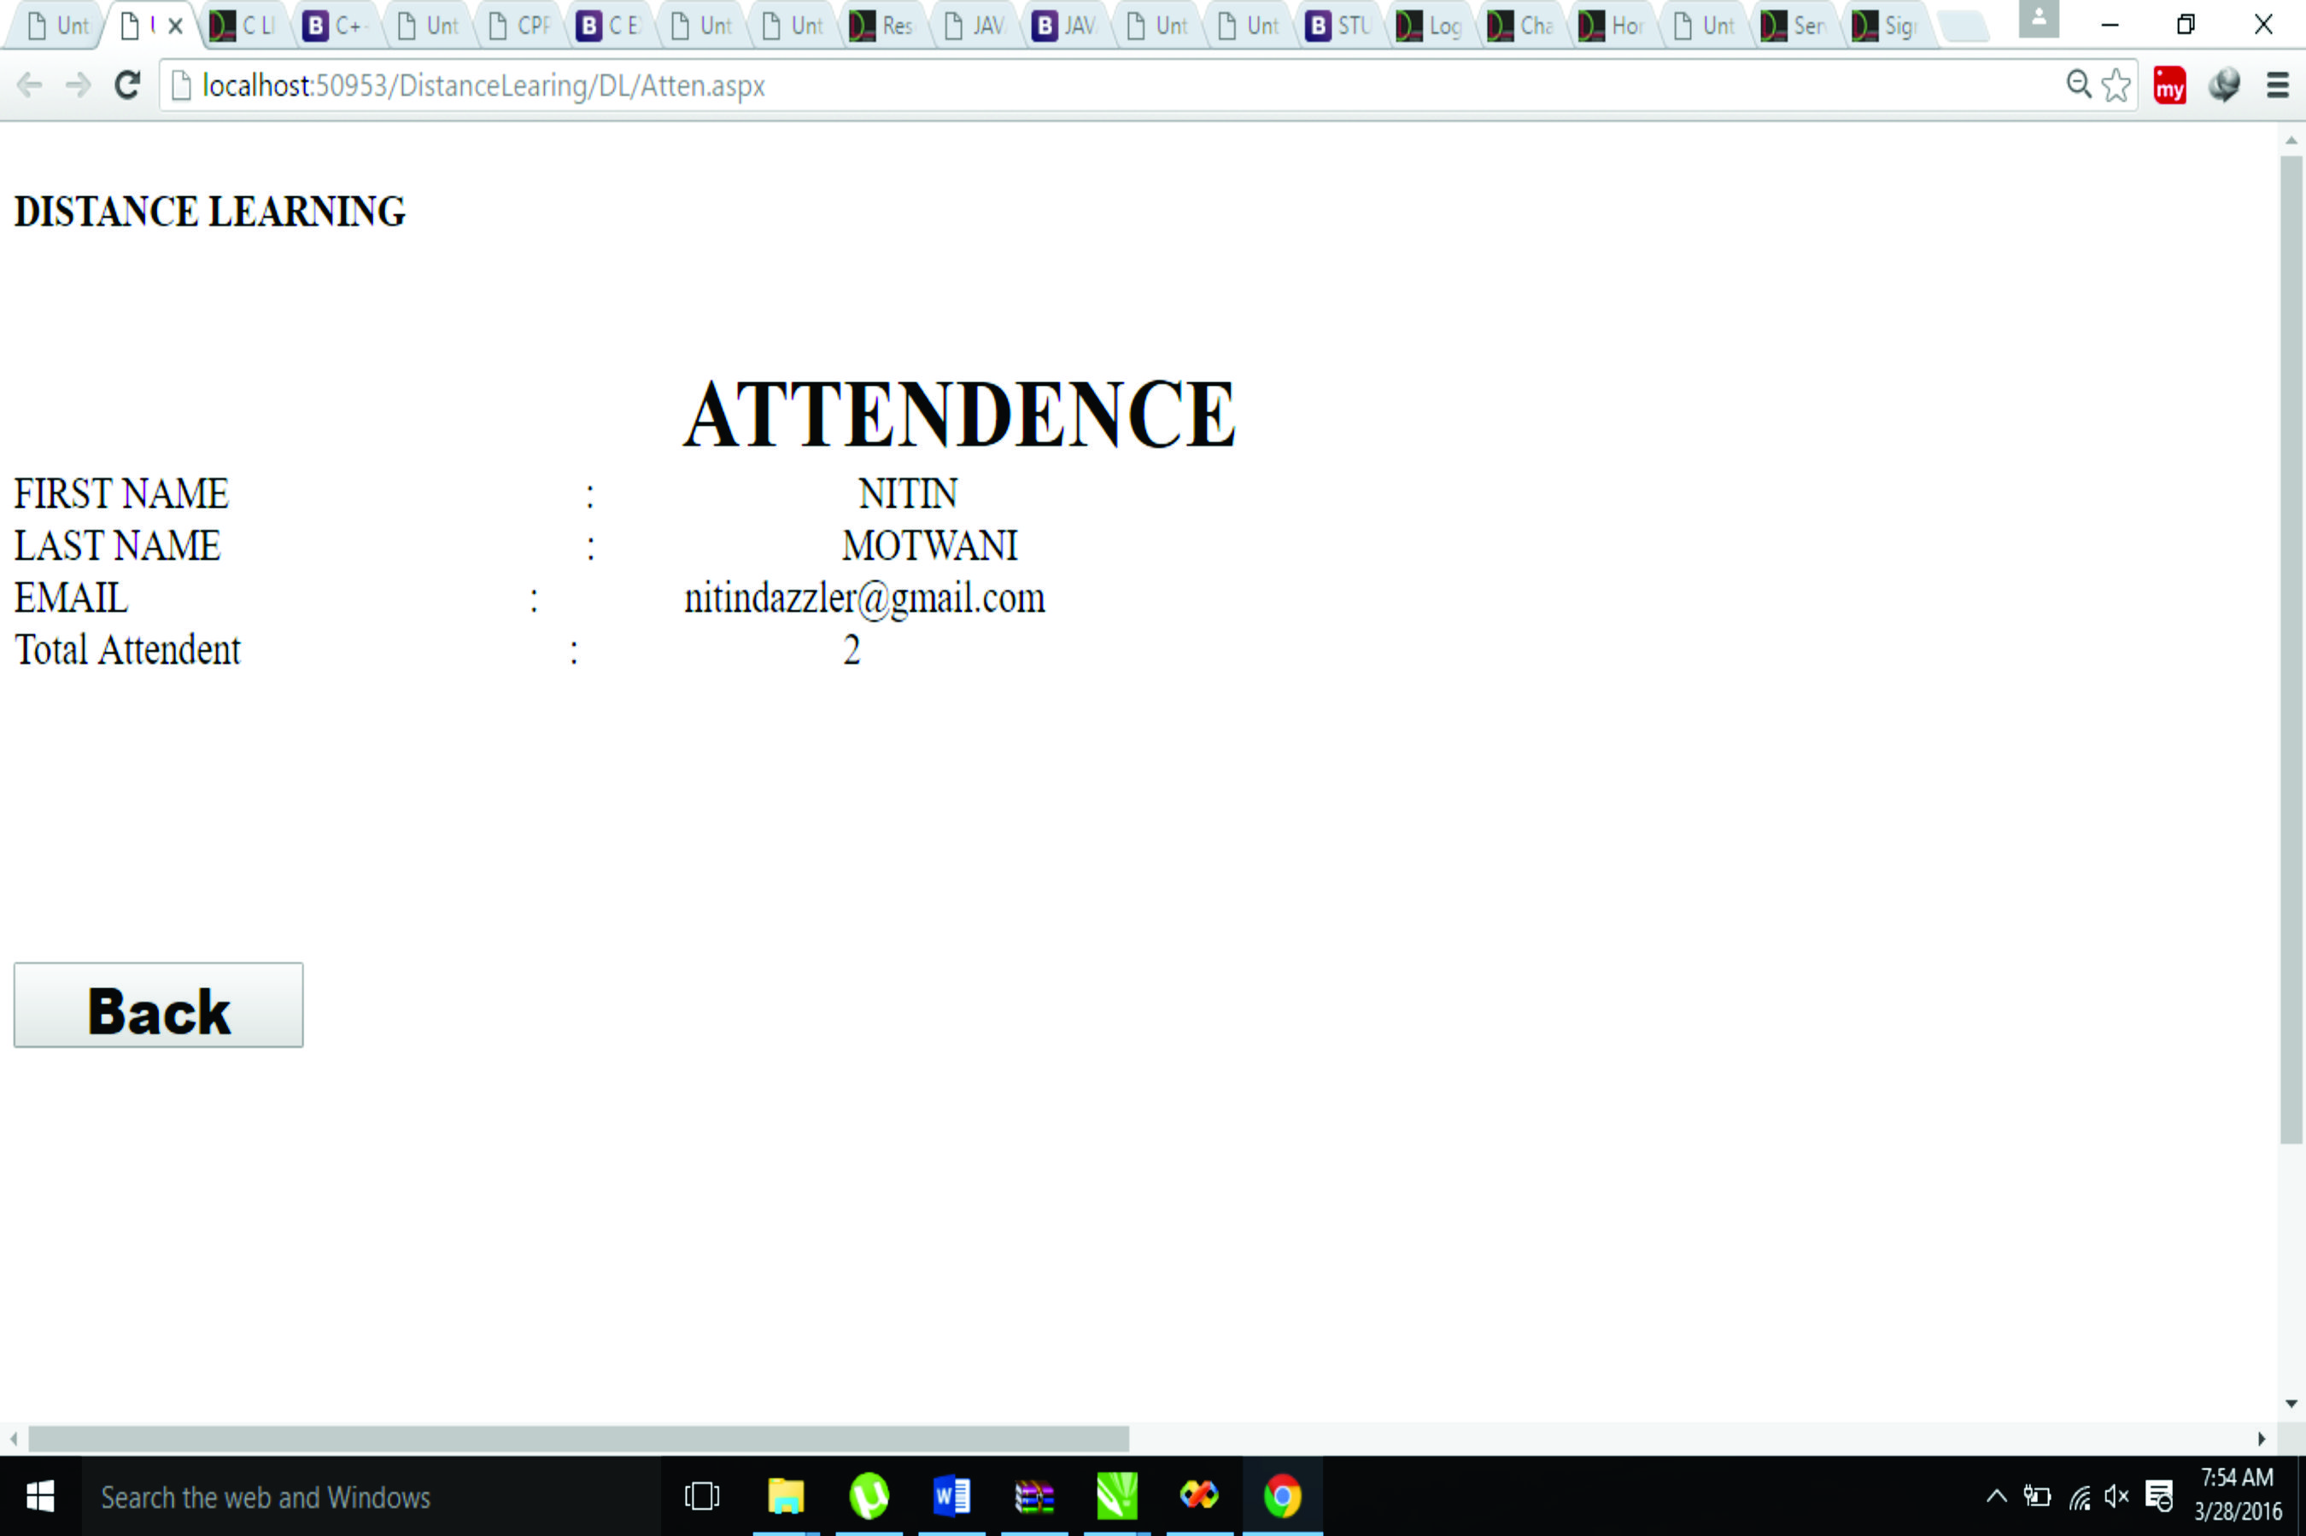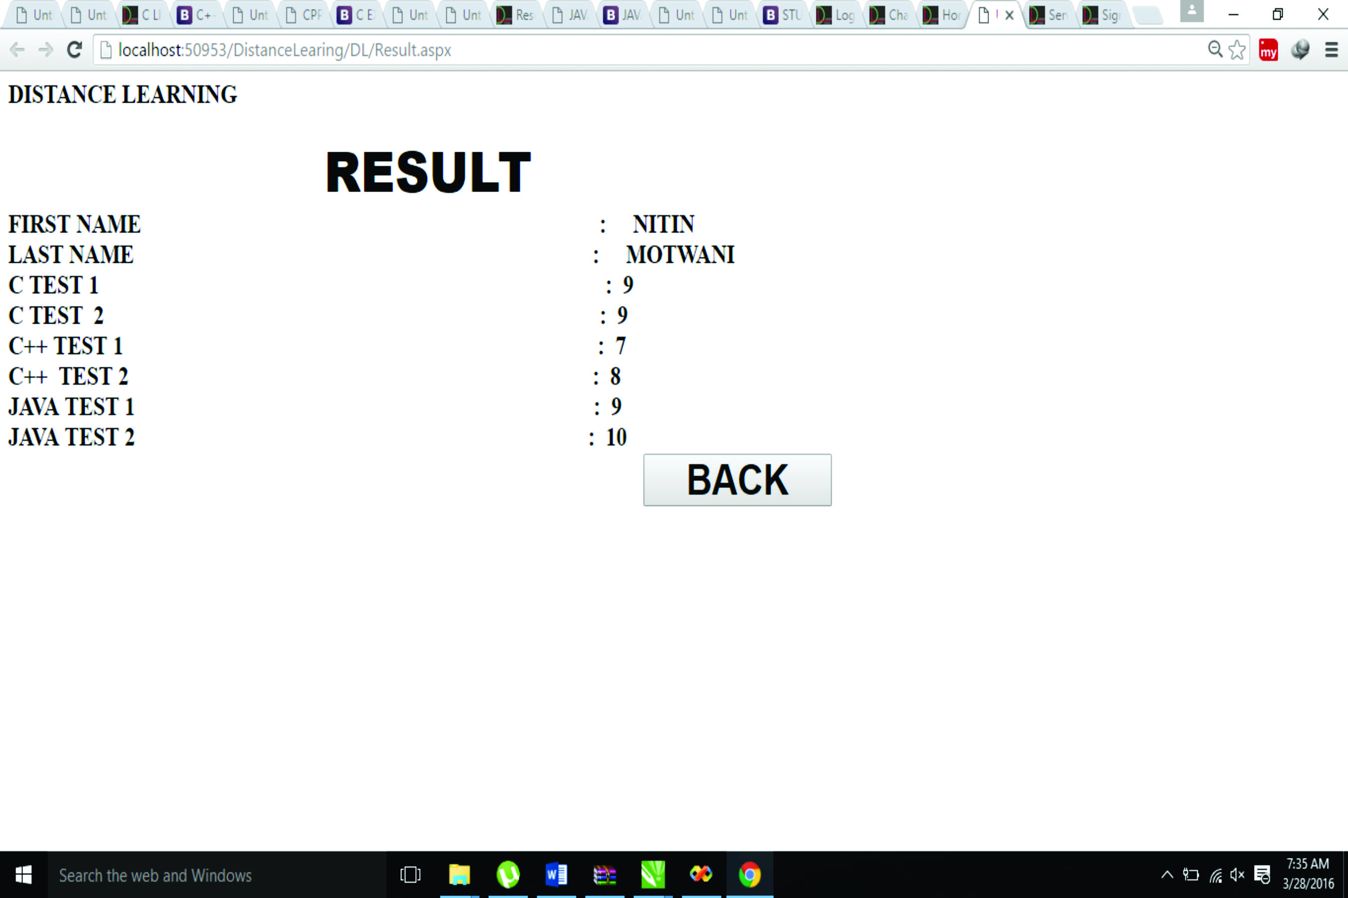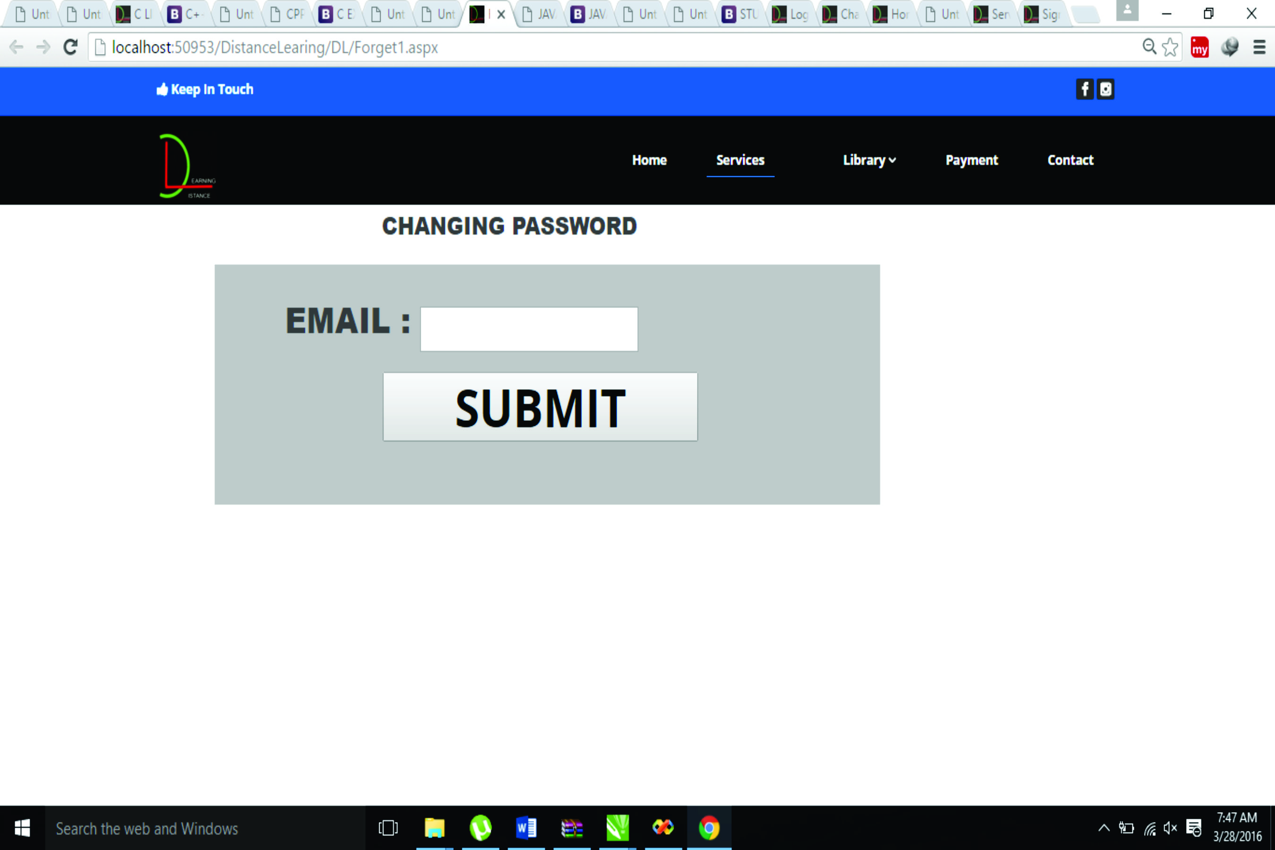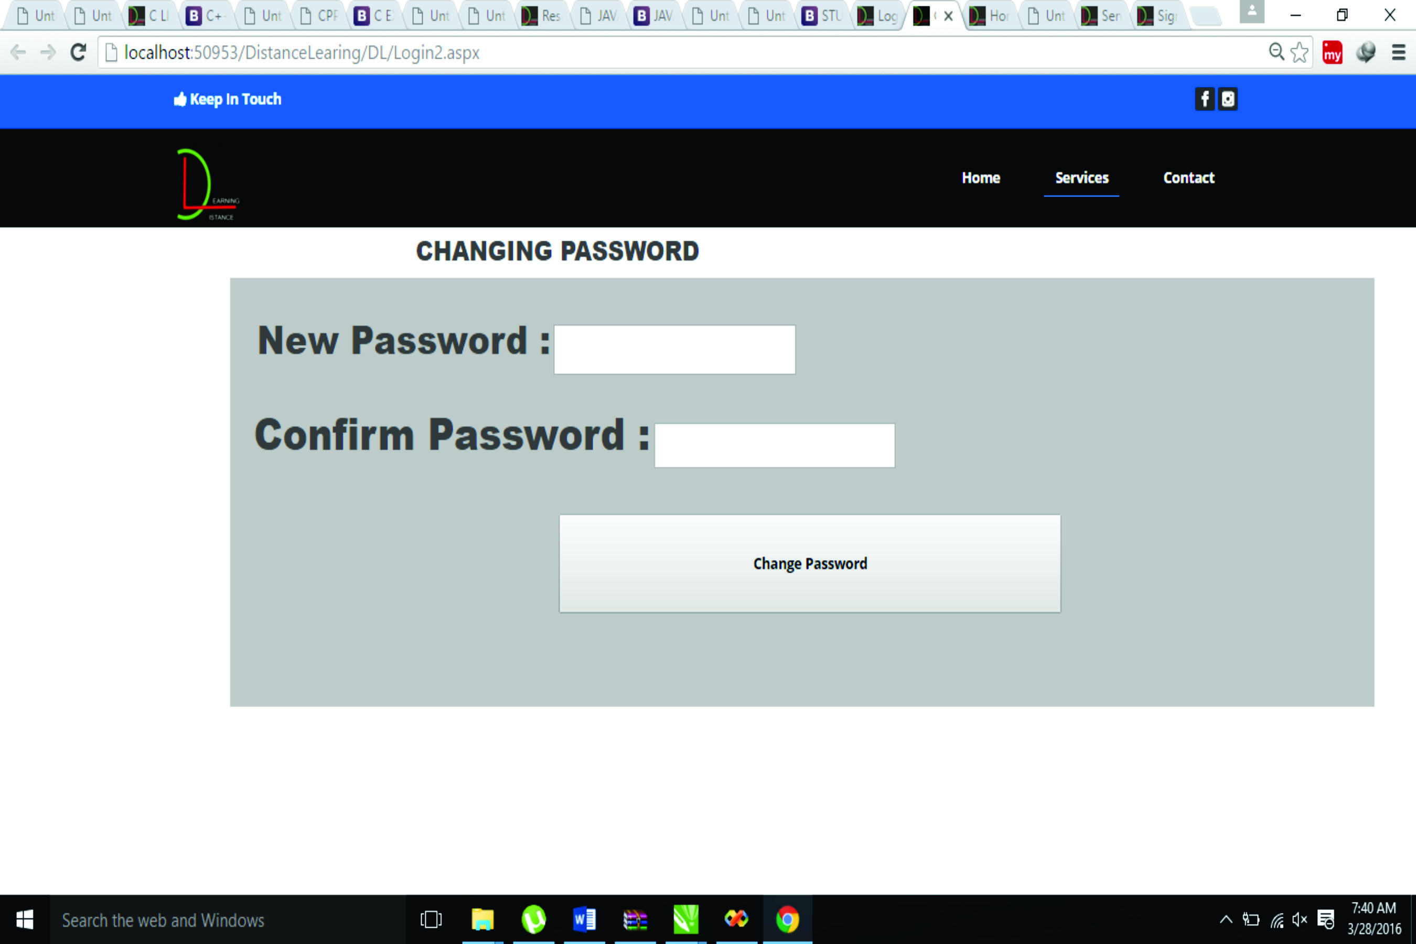

**ADVANTAGES**

**Advantages of Distance Learning Project:**

Distance learning, also known as online education, is a viable option for many individuals to get an education. It holds a number of pros and advantages over a traditional learning.

Advantages are as follows:-

* **Choice**: An online education provides the opportunity to study more subjects and reach out to programs that are not available in the immediate area.
* **Flexible**: Distance learning is much more flexible than traditional styles of classroom education. Students who need to take other classes or work can do class work whenever they have a free moment instead of being restricted to a rigid schedule.
* **Networking**: Students who enroll in classes with online education obtain a wider range of networking opportunities. Instead of being limited to networking in the local area, distance learning enables students to make connections with a more diverse range of people.
* **Money**: Online classes typically cost less than an education in a classroom environment. There are less space limitations and materials required for each student and the savings are passed on from the educational institution to each student.
* **Traveling**: A huge advantage to getting an online education is that there is no need to travel to and from class every single day. Someone who doesn’t drive or want to spend money on the costs of public transportation every single day will likely choose to get an online education over the traditional classroom.
* **Selection of Professors**: Distance learning enables students to learn from some of the most prestigious professors and guest speakers in each field.
* **No classroom sitting**: Sitting in the classroom is not the best way for every student to learn. A student may learn better at his own pace and in a different format than traditional schooling options offer.
* **Effective**: Online classes are just as, if not more, effective at teaching students than the traditional classroom style of learning
* **Pace**: Online education enables students to work at their own pace in many circumstances. The requirements are not as strict and typically give a range of due dates when the work needs to be submitted.
* **Scheduling**: The schedules for distance learning are more open and allow for students, parents and professionals to take the classes whenever it fits into their schedule. This is beneficial over classroom education that requires students to schedule work and childcare around the class time.

**FUTURE ENHANCEMENT**

**FUTURE ENHANCEMENT:**

1. Teachers could be given special logins and every teachers will just see and mark their own attendance report.
2. Special Administator login feature can be added.
3. Web Hosting can be used in order to launch the project for World-wide application.
4. Development for Android Application – Users can mark and see in your palmtop wherever you are and whenever possible through notifications.

**CONCLUSION**

* Distance Learning has proved to be a boon for students who stay far away from the universities in order to study for their career.
* The technology now exists to provide an effective and efficient distance education delivery system that overcomes the barriers that prevent individuals from achieving all they can through education: The barriers of distance, time, educational resources, and cost are being overcome with the continued refinement of distance learning programs.
* Distances learning programs attract students who differ significantly from each other in their learning styles, pace of learning, work experiences, and assessment preferences.
* Students are likely to do better when they know the course goals, see models and examples of "good work," and know how their performance compares with the acceptable standards.

Integrating assessment with instruction allows students to see the connection between their efforts and results and keeps them motivated to do well.

**REFERENCES**

[1]. First of all, we referred Symbiosis Centre of Learning College, Pune for Concept of Distance Learning and services provided to students. It is World Renowned University for MBA and various other courses providing Distance Learning as an option.

(http://www.scdl.com)



[2]. "The mission of the Center for Distance Learning Research at Texas A&M University is to provide timely and appropriate information on the development, application and maintenance of information technology systems. This information is provided through demonstration, training, publications and technical assistance. The Center’s services are available to all public agencies and private businesses who are interested in the welfare and education of people through the use of appropriate information technology and distance education." (http://www.cdlr.tamu.edu)



[3]. "ICDL is an internationally-recognized center for research, teaching, consultancy, information and publishing activities based in the UK Open University. ICDL promotes international research and collaboration by providing information from its library and databases" (http://www.icdl.open.ac.uk)



[4]. "The United States Distance Learning Association was the first nonprofit Distance Learning association in the United States to support Distance Learning research, development and praxis across the complete arena of education, training and communications. In 1987, the USDLA was founded on the premise of creating a powerful alliance to meet the burgeoning education and training needs of learning communities via new concepts of the fusion of communication technologies with learning in broad multidiscipline applications." (http://www.usdla.org)

